

**Arab Academy for Science, Technology and Maritime Transport**

College of Engineering and Technology

Smart Village Branch

Department of Electronics and Communication Engineering

B. Sc. Final Year Project

Intelligent Transport Systems Emulation Module

Presented By:

***Ali Yehia Abdelmonem***

***Mohamed Ihab Mekkawy Saad Tarek Shallan***

***Youssef Nasr Goma***

Supervised By:

***Prof. Hesham El-Badawy***

DEclaration

We hereby certify that this material, which I now submit for assessment on the programme of study leading to the award of Bachelor of Science in Electronics and Communications Engineering is entirely our own work, that we have exercised reasonable care to ensure that the work is original, and does not to the best of our knowledge breach any law of copyright, and has not been taken from the work of others save and to the extent that such work has been cited and acknowledged within the text of our work.

**Signed:** _____________________________

**Registration No.:** ___________

**Signed:** _____________________________

**Registration No.:** ___________

**Signed:** _____________________________

**Registration No.:** ___________

**Signed:** _____________________________

**Registration No.:** ___________

**Date:** 31, January 2023.

With sincere gratitude, we extend our heartfelt appreciation to Dr. Hesham Hamdy for his unwavering support and commitment throughout the entirety of our academic journey. His guidance and dedication, evident long before the inception of the last year project, have been instrumental in shaping our collective endeavors. Dr. Hesham's exceptional leadership in establishing and fostering our graduation project group exemplifies his profound commitment to the academic and professional development of each member. His tireless efforts to facilitate a collaborative and supportive environment have been a cornerstone in our pursuit of excellence. We are truly honored to express our appreciation for Dr. Hesham's invaluable contributions, his mentorship, and his steadfast commitment to the success of each individual within our academic community. This dedication is a testament to his enduring impact and serves as a token of gratitude for the guidance and inspiration he has generously bestowed upon us.

Acknowledgment

We would like to express our sincere gratitude to Prof. Hesham El-Badawy for his exceptional guidance across various dimensions of our academic journey. His continuous dedication to imparting not only technical expertise but also invaluable soft skills has been instrumental in our holistic development. Prof. El-Badawy's insightful teachings on effective presentation techniques, strategic task delegation, and critical thinking have significantly shaped our approach to problem-solving and project execution. His unwavering commitment to fostering a comprehensive learning experience has left an indelible mark on our academic pursuits.

Furthermore, we extend our heartfelt acknowledgment to Dr. Hatem Diab for the invaluable contributions to our academic growth. Dr. Diab's meticulous instruction on crafting formal reports and adhering to IEEE standards has been pivotal in enhancing the quality of our written work. His guidance has not only equipped us with the necessary skills for effective communication but has also played a crucial role in preparing us for the rigorous standards of academic publications. We are truly grateful for Dr. Diab's commitment to excellence in academia and for imparting the knowledge and skills that have significantly influenced our scholarly endeavors.

Abstract

This project presents the development of an Intelligent Transport Systems emulation module (ITS-EM) for the New Capital city in Egypt. The city is envisioned to be a smart, sustainable, and low-carbon urban center, and the ITS system is a crucial component in achieving this goal. The module integrates various technologies, including advanced information processing, data communication, electronic sensing, control systems, and AI deployment. The system is designed to optimize traffic flow, reduce congestion, increase traffic respect, and improve road safety.

The ITS emulation module is a critical aspect of the project, as it allows for the testing and validation of the system's performance before its deployment. The module simulates real-world traffic scenarios, enabling engineers to evaluate the system's effectiveness in various conditions. This approach helps to identify potential issues, reduce risks, and ensure the system's reliability before its implementation.

The project highlights the importance of the ITS system in promoting environment-friendly public transportation, and advancing the pilot study of intelligent connected vehicles. The system's complexity is addressed by breaking it down into smaller, manageable components, including fire suppression, weather information, light control, temperature and humidity, and vehicle weighing systems.

The development of the ITS emulation module is a significant step towards achieving the city's goal of becoming a smart, sustainable, and low-carbon urban center. The module's success will pave the way for the implementation of similar systems in other cities, contributing to a more sustainable and efficient transportation infrastructure.

Table of Contents

LIST OF FIGURES II

LIST OF TABLES IV

LIST OF ACRONYMS/ABBREVIATIONS V

1 INTRODUCTION 1

1.1 HISTORY 2

1.2 PROBLEM STATEMENT 4

1.3 OBJECTIVE 4

2 METHODOLGY 5

2.1 INDIVIDUAL SYSTEMS AND OUTPUT ACCTUATORS RESEARCH 5

2.1.1 System 1: WIM: Intelligent Truck Weighing Management System 5

2.1.2 System 2: Fire Suppression 10

2.1.3 System 3: Road Weather Information 16

2.1.4 System 4: Automatic Vehicle Identification and Toll Collection 18

2.1.5 System 5: Lighting Control 25

3 EXPERMIENT AND RESULTS 28

3.1 System 1: WIM: Intelligent Truck Weighing Management System 28

3.1.1 Load Cell and HX711 Amplifier 28

3.2 System 2: Fire Suppression 39

3.2.1 Flame Sensor Module LM393 39

3.3 System 3: Road Weather Information 48

3.3.1 Humidity and Temperature Module DHT22 48

3.4 System 4: Automatic Vehicle Identification and Toll Collection 57

3.4.1 Radio Frequency Identification 57

3.5 System 5: Lighting Control 67

3.5.1 Light sensor TSL2561 67

3.6 Integration and System Prototype 73

4 FUTURE WORK 74

REFERENCES 75

LIST OF FIGURES

Figure ‎1‑1: Intelligent Transportation System. [1] 2

Figure ‎2‑1: Example of Weigh-in-Motion system. [2] 6

Figure ‎2‑2: Factors affecting the weighing accuracy. [2] 6

Figure ‎2‑3: (a) Polymer sensor installed below the pavement surface. (b) Quartz sensor installed on the level of the pavement surface. (c) Bending plate sensor installed on the level of the pavement surface. (d) Capacitive sensor installed on the level of the pavement surface. [2] 8

Figure ‎2‑4: Car caught on fire insde a tunnel. [3] 10

Figure ‎2‑5: Analysis of the received signal under normal and fire conditions. [3] 11

Figure ‎2‑6: Example of cross-section of an equipped road tunnel. [4] 12

Figure ‎2‑7: Pre-engineered CAFS (Compressed Air Foam System) fire suppression unit for automatic tunnel fire detection and extinction. [5] 13

Figure ‎2‑8: Compressed air foam erupts from strategically placed nozzles, quickly suppressing a tunnel fire. [5] 14

Figure ‎2‑9: Successfully extinguished vehicle. [5] 14

Figure ‎2‑10: Prominent signage installed at the tunnel entrance to alert incoming drivers of a potential hazardous situation within the tunnel. [3] 15

Figure ‎2‑11: Typical location of tower-based sensors for weather monitoring. [7] 16

Figure ‎2‑12: Signage message to alert drivers of the road conditions. 17

Figure ‎2‑13: Automatic number plate recognition system. [8] 18

Figure ‎2‑14: Automatic number plate recognition system. [9] 19

Figure ‎2‑15: Real-time monitoring of passing vehicles. [9] 19

Figure ‎2‑16: Automatic number plate recognition under different conditions. [10] 20

Figure ‎2‑17: Fuel consumption vs. speed. [12] 22

Figure ‎2‑18: Street lights control by targeted dimming of LED lights. [16] 25

Figure ‎2‑20: Smart and sustainable lighting benefits. [17] 27

Figure ‎3‑1: Load Cell Circuit Diagram. [20] 29

Figure ‎3‑2: 20 KG load cell weight sensor. [20] 32

Figure ‎3‑3: Voltage difference of load cell when no weight applied. [20] 33

Figure ‎3‑4: Voltage difference of Wheatstone bridge when weight applied. [20] 34

Figure ‎3‑5: Connections of load cell to the HX711 module and Arduino. [20] 34

Figure ‎3‑6: No force applied. [23] 35

Figure ‎3‑7: Force applied. [23] 35

Figure ‎3‑8: Sample project of load cell with HX711 amplifier on Proteus using Arduino. 36

Figure ‎3‑9: Intelligent truck weighing management system. 37

Figure ‎3‑10: No load. 38

Figure ‎3‑11: Calculated fee for the applied load. 38

Figure ‎3‑12: Flame Sensor Module Circuit Diagram. [26] 39

Figure ‎3‑13: Pinsfunctions. [26] 42

Figure ‎3‑14: Flame sensor module output when no fire in range. [26] 43

Figure ‎3‑15: Flame sensor module output when fire in range. [26] 43

Figure ‎3‑16: Interfacing flame sensor on proteus with test pin is low. 44

Figure ‎3‑17: Interfacing flame sensor on proteus with test pin is high. 44

Figure ‎3‑18: When fire is detected, warning message is displayed, and the water pump activates. 46

Figure ‎3‑19: Fire suppression system remains idle when there is no fire detected. 47

Figure ‎3‑20:DHT22 Sensor Module Circuit Diagram. 48

Figure ‎3‑21: Pins functions. 51

Figure ‎3‑22: DHT22 sensor parts. [30] 52

Figure ‎3‑23:Interfacing DHT22 sesnsor on Proteus. 53

Figure ‎3‑24: Assisting fan inactive when temperature below 23 degree. 55

Figure ‎3‑25: Assisting fan active when temperature above 23 degrees. 56

Figure ‎3‑26: RFID working principle. 57

Figure ‎3‑27: RC522 RFID Module Pinout. 62

Figure ‎3‑28: Interfacing RFID on Proteus. 63

Figure ‎3‑29: Automatic tolling and vehicle identification hardware. 65

Figure ‎3‑30: (a) Access granted for valid ID. (b) Door closed after a few seconds of passage. 66

Figure ‎3‑31: Access denied for invalid ID. 66

Figure ‎3‑32: Light Sensor TSL2561 Circuit Diagram. [32] 67

Figure ‎3‑33: TSL2561 module pinout. 68

Figure ‎3‑34: Lights automatically turn off when ambient light levels are sufficient. 71

Figure ‎3‑35: Lights automatically turn on when ambient light levels become insufficient. 72

Figure ‎3‑36: Integrated systems prototype. 73

LIST OF TABLES

Table ‎2‑1: Vehicle Passed Away from Toll Booth in 1 year. [11] 21

Table ‎2‑2: Fuel Consumption, CO2 Emissions and Savings. [12] 23

Table ‎3‑1: Comparison between load cell weight sensor and bathroom scale weight sensor 30

Table ‎3‑2: 20 KG Load Cell Weight Sensor Specifications. [21] 31

Table ‎3‑3: Selection criteria of flame sensor module LM393. 40

Table ‎3‑4: Flame sensor module specifications. 41

Table ‎3‑5: Selection criteria for DHT22 sensor module. 49

Table ‎3‑6: DHT22 sensor specifications. 50

Table ‎3‑7: RC522 RFID specifications. 61

Table ‎3‑8: TSL256 light sensor module specifications 70

LIST OF ACRONYMS/ABBREVIATIONS

|  |  |
| --- | --- |
| ADAS | Advanced Driver Assistance Systems |
|  |  |
| ANPR | Automatic Number Plate Recognition |
|  |  |
| ATIS | Expansion into Advanced Traveler Information Systems |
|  |  |
| ATMS | Introduction of Advanced Traffic Management Systems |
|  |  |
| AVITC | Automatic Vehicle Identification and Toll Collection |
|  |  |
| CAFS | Compressed Air Foam System |
|  |  |
| CCTV | Closed-Circuit Television |
|  |  |
| GUI | Graphical User Interface |
|  |  |
| GPS | Global Positioning System |
|  |  |
| IoT | Internet of Things |
|  |  |
| ITS-EM | Intelligent Transport Systems Emulation Module |
|  |  |
| NFPA | National Fire Protection Association |
|  |  |
| RFID | Radio Frequency Identification |
|  |  |
| ROS | Return On Investment |
|  |  |
| RWIS | Road Weather Information System |
|  |  |
| V2I | Vehicle-to-Infrastructure |
|  |  |
| V2V | Vehicle-to-Vehicle |
|  |  |
| WIM | Weigh-in-Motion |
|  |  |

Chapter One

# INTRODUCTION

The term intelligent transportation system (ITS) refers to efforts to add information and communications technology to transport infrastructure and vehicles, in order to improve safety and reduce vehicle wear, transportation times, and fuel consumption. ITS are advanced applications which, without embodying intelligence as such, aim to provide innovative services relating to different modes of transport and traffic management and enable various users to be better informed and make safer, more coordinated, and 'smarter' use of transport networks as in Figure ‎1‑1.

Interest in ITS comes from the problems caused by traffic congestion and a synergy of new information technology for simulation, real-time control, and communications networks. Traffic congestion has been increasing worldwide as a result of increased motorization, urbanization, population growth, and changes in population density. Congestion reduces efficiency of transportation and increases travel time, air pollution, and fuel consumption

Intelligent transport systems vary in technologies applied, from basic management systems such as car navigation; traffic signal control systems; container management systems; variable message signs; automatic number plate recognition or speed cameras to monitor applications, such as security Closed-circuit television (CCTV) systems; and to more advanced applications that integrate live data and feedback from a number of other sources, such as parking guidance and information systems; weather information; bridge deicing systems; and the like. Additionally, predictive techniques are being developed to allow advanced modeling and comparison with historical baseline data. Some of these systems are implemented in this project such as automatic vehicle tooling and identification, light control, vehicle weighing, temperature and humidity, and fire suppression systems.

## HISTORY

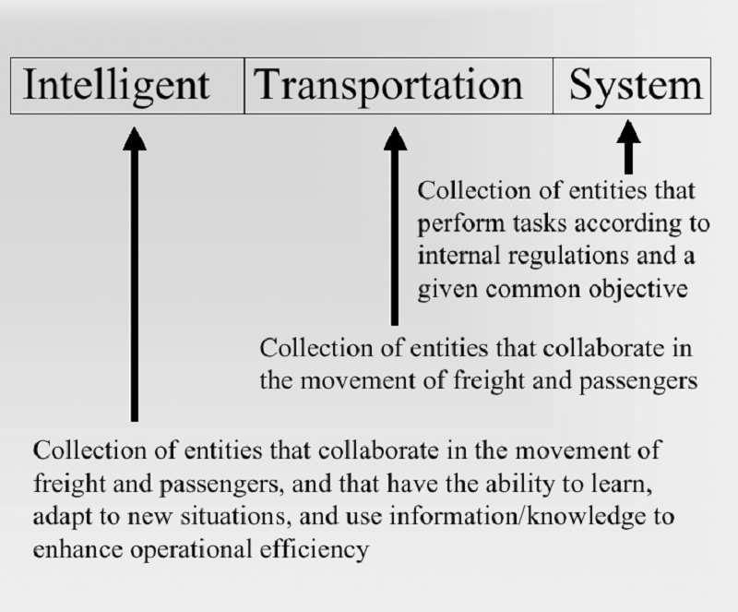

Figure ‎1‑1: Intelligent Transportation System. [1]

Intelligent Transport Systems (ITS) have evolved over several decades, leveraging advancements in technology to enhance transportation efficiency, safety, and sustainability. Here's a brief history:

1. 1960s-1970s: Emergence of Traffic Control Systems:
   * The early stages of ITS saw the development of basic traffic control systems, including the use of traffic signals and rudimentary sensor technologies for traffic management.
2. 1980s: Introduction of Advanced Traffic Management Systems (ATMS):
   * The 1980s marked the introduction of more sophisticated ATMS, incorporating computerized control systems, advanced traffic signal coordination, and early versions of traffic surveillance cameras.
3. 1990s: Expansion into Advanced Traveler Information Systems (ATIS):
   * ITS expanded its focus to include ATIS, providing real-time information to travelers about traffic conditions, alternative routes, and transit schedules. The emergence of the internet facilitated the dissemination of information to a broader audience.
4. Late 1990s-2000s: Integration of Communication Technologies:
   * The late 1990s and early 2000s witnessed the integration of communication technologies, including the use of wireless networks and the Global Positioning System (GPS). This facilitated the development of more sophisticated navigation and tracking systems.
5. 2000s: Intelligent Vehicle Technologies and Connected Vehicles:
   * The 2000s saw a significant focus on intelligent vehicle technologies, including the development of advanced driver assistance systems (ADAS) and the concept of connected vehicles. These technologies aimed to enhance safety through vehicle-to-vehicle (V2V) and vehicle-to-infrastructure (V2I) communication.
6. 2010s: Emergence of Autonomous Vehicles and Smart Cities:
   * The 2010s witnessed a surge in research and development related to autonomous vehicles, with major advancements in sensor technologies, machine learning, and artificial intelligence. The concept of Smart Cities gained prominence, focusing on the integration of ITS with urban infrastructure for more efficient and sustainable transportation.
7. 2020s: Continued Advancements in Connectivity and Sustainability:
   * In the current decade, ITS continues to evolve with a strong emphasis on connectivity, data analytics, and sustainability. The integration of 5G networks, the Internet of Things (IoT), and big data analytics further enhances the capabilities of ITS in optimizing transportation systems.

## PROBLEM STATEMENT

In the context of building New Capital city as a dynamic growth smart city in Egypt, the deployment of Intelligent Transport Systems (ITS) is a key strategy for creating a safe, sustainable, and efficient urban environment. However, ITS projects are complex due to the integration of multiple advanced technologies and components. This project involves information processing, data communication, electronic sensing, control technology, the Internet of Things (IoT), and cloud computing, among others. Managing and implementing such systems requires careful planning, design, and testing to minimize risks and meet the needs of users.

## OBJECTIVE

* Studying the ITS main features.
* Establishing the system design and selecting suitable components.
* Circuit design, schematic, and implementation via discreet components and
* or Arduino, or Raspberry PI and suitable Graphical user interface (GUI).
* Fabricating the PCB layout and assembling the system prototype.
* ITS-EM testing for various operational scenarios.
* Chapter Two

# METHODOLGY

We aim to implement various functions of Intelligent Transportation Systems (ITS), including Humidity, Speed, Weight Sensing, Temperature, and the signage process. This implementation will be orchestrated by a centralized controller, utilizing platforms such as Raspberry Pi or Arduino. The execution will involve deploying different sensors and orchestrating operations between them to achieve full controllability and manageability of the system. The goal is to enhance and implement an ITS emulation on a modular basis, serving as a proof of concept (POC). This POC of the ITS will be utilized to investigate and illustrate different functionalities, such as RFID integration, car recognition, safety measures, toll counting, road management, and more.

## INDIVIDUAL SYSTEMS AND OUTPUT ACCTUATORS RESEARCH

### System 1: WIM: Intelligent Truck Weighing Management System

Weigh-in-motion (WIM) systems are an array of sensors used to measure various features of vehicles in motion. WIM systems are comprised of not only the electronics and sensors but also, just as importantly, flat, smooth, and straight roadways as shown in Figure ‎2‑1 below. The WIM system is designed based on shortening weighing time, improving efficiency, and ensuring the weighing fairness. It is used for automatically collecting weights of trucks, monitoring truck weighing, inputting and reading of IC card data, automatically permitting truck’s leaving after weighing, and so on.

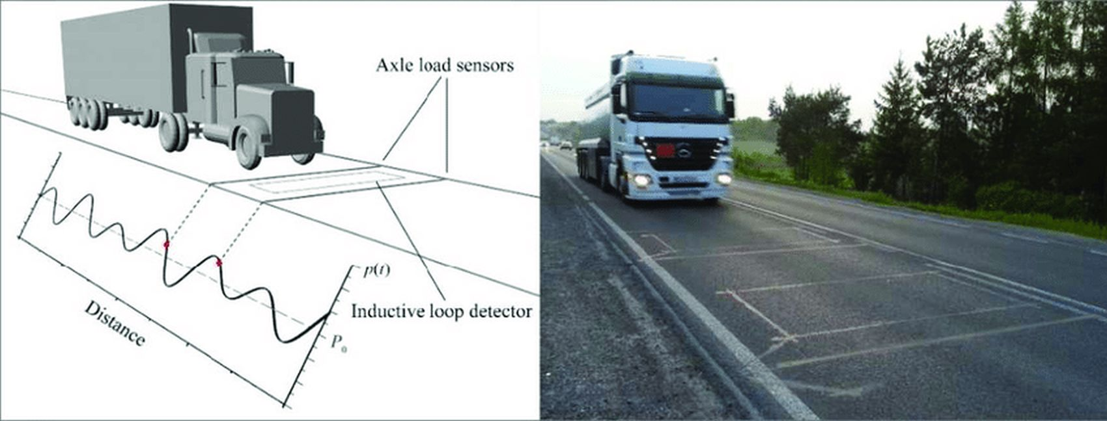

Figure ‎2‑1: Example of Weigh-in-Motion system. [2]

During the early stages of WIM system development, the changeable wheel load of a moving vehicle was thought to be the only source of substantial inaccuracy in weighing findings. A further in-depth research, however, revealed that there were additional elements interfering with the measurement [2], such as road roughness, pavement temperature, wheel load value, vehicle speed, and weather conditions, among others. These factors have an impact on all types of axle load sensors, regardless of sensor technology. We classified them based on the source of their occurrence (vehicle or WIM system) or the degree of influence (primary or secondary). Figure ‎2‑2 shows one such division.

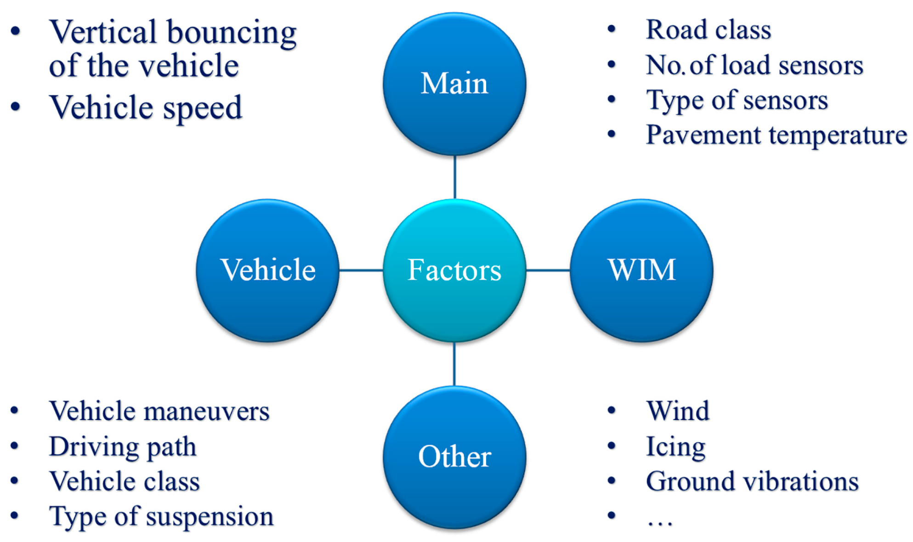

Figure ‑: Factors affecting the weighing accuracy. [2]

#### Literature Review

The literature survey reveals critical facets of advancing Weigh-in-Motion (WIM) systems. Firstly, the imperative to enhance WIM system accuracy is underscored, as this is integral for certification by National Metrological Institutes. Certification empowers WIM systems to directly enforce weight restrictions, presenting a substantial solution to reducing overloaded vehicles. Furthermore, the reduction of overloading carries significant implications for pavement maintenance, potentially extending serviceability and reducing associated costs. Studies highlight that the 15% to 30% of heavy traffic constituted by overloaded vehicles can contribute up to 70% of pavement fatigue damage. Notably, instances such as the reduction from 30% to 2% of overloaded vehicles in New York State demonstrate that increased enforcement can potentially double pavement fatigue life, yielding both economic and social benefits. WIM systems, beyond their weighing functionality, provide valuable statistical insights for traffic management, flow optimization, and infrastructure design for pavements and bridges. The survey also delves into the temperature sensitivity of axle load sensors, revealing variations among sensor types, particularly polymer and ceramic sensors, which are sensitive to pavement temperature, unlike quartz sensors. Moreover, the research indicates that different sensor types respond differently to changes in vehicle speed, with polymer sensors being less speed-sensitive, quartz sensors performing better at higher speeds, and ceramic sensors showing more variable results [2].

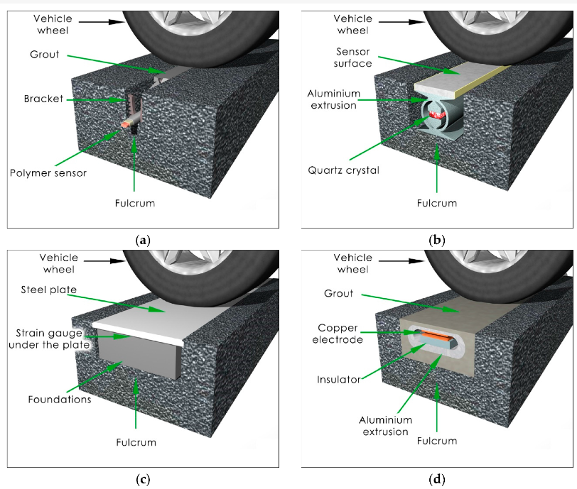

Figure ‑: (a) Polymer sensor installed below the pavement surface. (b) Quartz sensor installed on the level of the pavement surface. (c) Bending plate sensor installed on the level of the pavement surface. (d) Capacitive sensor installed on the level of the pavement surface. [2]

The installation of axle load sensors in WIM systems involves embedding them in the pavement perpendicular to the traffic flow. Presently, WIM systems utilize sensors employing four different technologies: piezoelectric (polymer or ceramic), quartz, bending plate, and capacitive. Although fiber-optic sensors, a promising technology, are not yet in use, literature contains information about their testing. Regarding installation methods, WIM sensors are categorized into two groups: those placed in a small cut in the pavement at a depth of 2 to 10 cm, depending on the sensor type (Figure ‎2‑3: (a)), where the sensor lacks direct contact with the vehicle wheel, and axle load is transmitted via the pavement and installation grout; this method is employed for polymer and piezo-ceramic sensors. The second group involves sensors installed in a cut in the pavement at the surface level (Figure ‎2‑3: (b-d)), allowing direct contact with the vehicle wheel. This method is applied for quartz, bending plate, and capacitive sensors [2].

In both mounting methods, the pavement serves as the fulcrum for the sensor. When the sensor is installed beneath the road surface, the wheel load is conveyed to the sensor through the pavement and the grout used for installation. This distinctive situation underscores the pavement's crucial role in the measuring process, transforming it from a mere road component to an integral part of the weighing system. Consequently, the properties of the pavement exert an influence on the overall WIM system properties. To address potential weighing errors, the proposal is to categorize them into two groups: the sensor intrinsic error, linked to variations in the sensor's electrical parameters due to temperature changes, and the pavement/sensor complex external error, which encompasses the sensor intrinsic error along with additional errors occurring post-installation in the pavement. The pavement is identified as the source of these errors, with its properties being influenced by temperature and the duration of force applied by the vehicle wheel on the pavement/sensor complex. The challenge in achieving accurate vehicle weighing in motion stems from the significant impact of the pavement/sensor complex external error. Previous research highlighted three influential factors:

* Changes in pavement temperature.
* Duration of forces applied to the pavement/axle load sensor complex linked to the vehicle's speed.
* Stress on the tire-pavement contact area, which depends on wheel force values.

### System 2: Fire Suppression

The National Fire Protection Association, generally known as the NFPA, has codes that govern fire suppression systems. This organization creates codes, regulations, and recommendations for fire suppression system installation and maintenance. Similarly, the NFPA specifies standards that must be met for various types of fire suppression systems.

The fundamental issue with tunnel fires is the high fire dynamic combined with typically restricted evacuation options. As a result, it is critical to detect and combat fires as early as possible - with stationary equipment, even in the critical minutes before the arrival of the fire department.

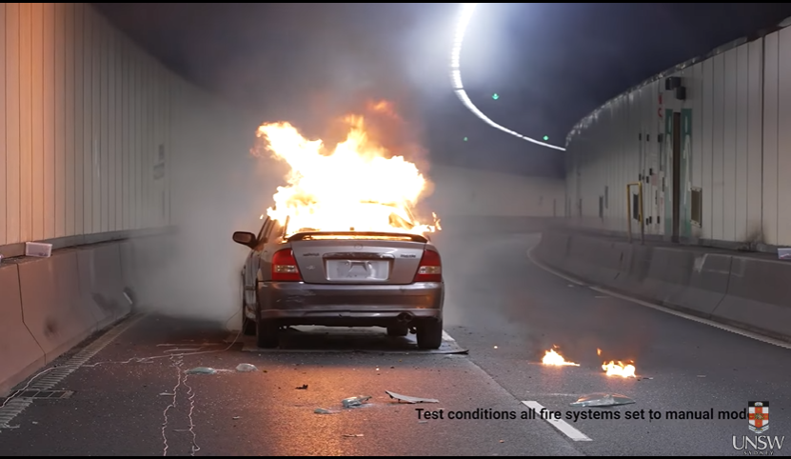

Figure ‎2‑4: Car caught on fire insde a tunnel. [3]

Figure ‎2‑4 shows when a car catches fire inside a tunnel, it presents a multifaceted and critical problem. Firstly, the confined space of a tunnel significantly exacerbates the dangers of a fire, including intense heat, toxic fumes, and reduced visibility. This can lead to a rapid increase in temperature and accumulation of smoke, making evacuation and rescue operations more challenging. Secondly, the lack of natural ventilation in tunnels hinders the dissipation of smoke and heat, posing serious risks to trapped individuals and complicating firefighting efforts. Furthermore, the structural integrity of the tunnel can be jeopardized due to the high temperatures of a vehicle fire, potentially leading to long-term closures for repairs. This not only disrupts traffic

but also can have significant economic impacts. Additionally, in the case of tunnels that are part of critical infrastructure or major transport routes, such an incident can have far-reaching effects on mobility and logistics. Therefore, ensuring robust fire safety measures and quick response systems in tunnels is crucial for mitigating these risks.

USNW Sydney have developed a new inexpensive Wi-Fi system that enhances fire detection capabilities. The system utilizes Wi-Fi signals and a machine learning algorithm to detect and monitor fire incidents in real-time. The system's machine learning algorithm is trained on various fire scenarios to accurately differentiate between normal activities and potential fire incidents. By continuously monitoring the Wi-Fi signals and analyzing their patterns, the system can quickly detect the presence of a fire and alert building occupants or emergency responders as in Figure ‎2‑5. “Existing specialized fire detection cameras can cost around $10,000 to buy, whereas our transmitters and receivers are $100 or even less,” Prof. Seneviratne says. This makes the system highly scalable and applicable to a wide range of environments, including residential, commercial, and industrial buildings. The article highlights that this Wi-Fi-based fire detection system has shown promising results in early testing. Further research and development are needed to optimize the system's accuracy and reliability, as well as to integrate it with existing fire suppression and alarm systems [3].

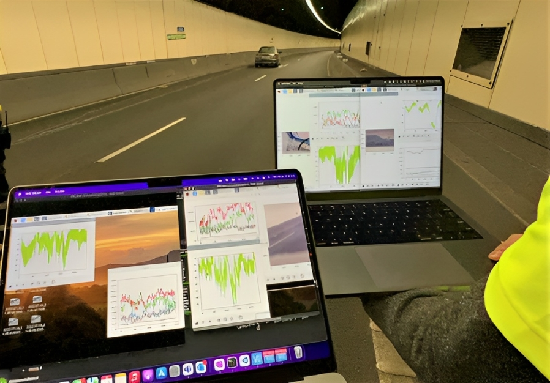

Figure ‑: Analysis of the received signal under normal and fire conditions. [3]

Designing tunnels with specific features and capabilities to address the risks associated with fire incidents is of paramount importance for public safety and infrastructure resilience. The confined nature of tunnels amplifies the challenges posed by fires, including heightened temperatures, toxic fumes, and limited visibility. Incorporating essential elements such as advanced ventilation systems, strategically placed cameras, effective illumination, and efficient water drainage becomes crucial in mitigating these risks. Adequate ventilation not only helps disperse smoke and heat but also facilitates quicker response times for emergency personnel. Surveillance cameras enhance real-time monitoring, aiding in the early detection of fires and enabling swift intervention. Illumination systems ensure visibility remains optimal, assisting in safe evacuation and firefighting operations. Additionally, effective water drainage systems help prevent water accumulation, allowing for a more efficient response and minimizing potential damage to tunnel infrastructure. By integrating these capabilities into tunnel design, authorities can significantly enhance their ability to detect, respond to, and mitigate the impact of fires, ultimately safeguarding lives, minimizing economic disruptions, and maintaining the integrity of critical transportation routes. Figure ‎2‑6 below is an example of a road tunnel with some of the addressed capabilities.

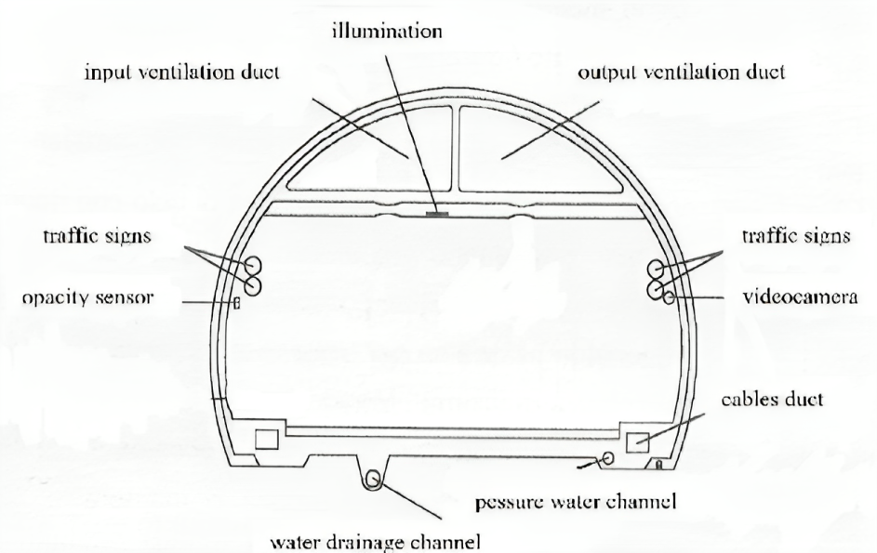

Figure ‑: Example of cross-section of an equipped road tunnel. [4]

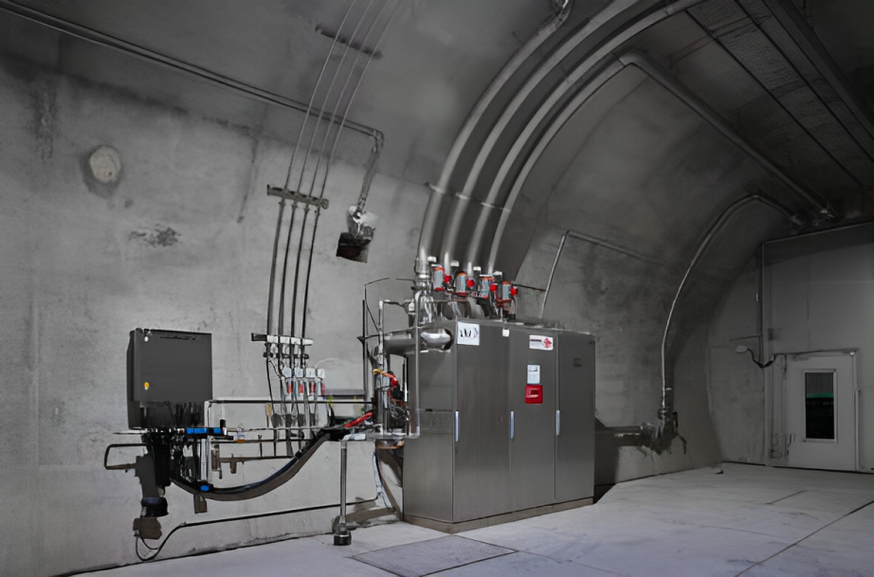

Figure ‑: Pre-engineered CAFS (Compressed Air Foam System) fire suppression unit for automatic tunnel fire detection and extinction. [5]

The implementation of a pre-engineered Compressed Air Foam System (CAFS) shown in Figure ‎2‑7 in tunnel environments marks a significant advancement in fire suppression technology. This system is specifically designed for automatic detection and extinguishment of fires in tunnel settings. Utilizing a mixture of water, foam concentrate, and compressed air, CAFS creates a fire-suppressing foam that is more effective than water alone in both cooling the fire and coating the fuel surface, thereby preventing re-ignition. Its automated nature allows for rapid detection and response to a fire outbreak, a crucial factor in the confined and potentially hazardous environment of a tunnel. Upon detection of a fire, the system swiftly activates, discharging the foam to the affected area, significantly reducing the spread and intensity of the fire. This rapid response not only enhances safety for tunnel users but also minimizes structural damage. For a more detailed illustration of this system in action, refer to Figure ‎2‑8, which provides a comprehensive visual representation of the CAFS in a tunnel fire scenario. And Figure ‎2‑9 after extinguishing the fire.

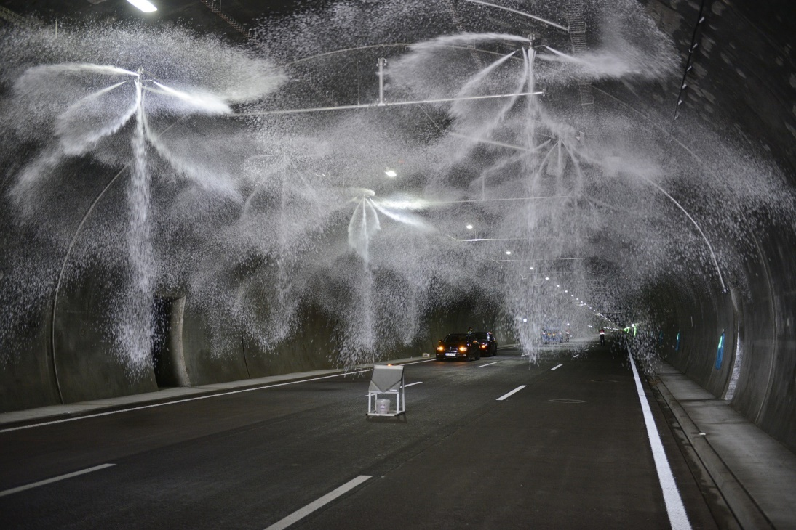

Figure ‎2‑8: ****Compressed air foam erupts from strategically placed nozzles, quickly suppressing a tunnel fire.**** [5]



Figure ‑: Successfully extinguished vehicle. [5]

Figure ‑: ****Prominent signage installed at the tunnel entrance to alert incoming drivers of a potential hazardous situation within the tunnel.**** [3]

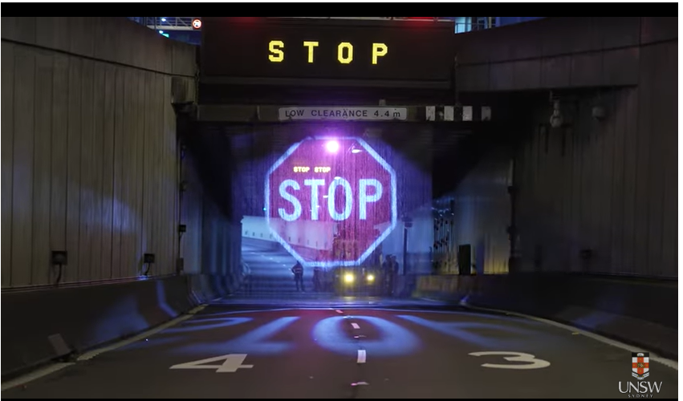

Signage message to stop incoming vehicles from entering tunnel

Hologram

In tandem with the advanced fire suppression systems like the pre-engineered Compressed Air Foam System (CAFS), the deployment of dynamic signage outside tunnels in the event of a fire is equally critical. This signage plays a vital role in alerting incoming drivers about the hazardous situation inside the tunnel, effectively preventing them from entering a potentially life-threatening environment. By doing so, it not only safeguards the lives of additional road users but also reduces the risk of exacerbating the fire or causing chain reaction incidents, which can lead to more significant damage and complicate rescue and firefighting efforts. The strategic placement of these signs and their ability to convey urgent warnings in real-time are essential for maintaining safety and managing traffic flow during emergencies. For a visual depiction of how these signage systems operate during a tunnel fire, refer to Figure ‎2‑10, which demonstrates the positioning and function of these critical warning systems.

### System 3: Road Weather Information

The Road Weather Information System (RWIS) is a technology-driven system that provides real-time weather information and road condition data to drivers, transportation agencies, and other stakeholders. It consists of a network of sensors strategically placed along roads to collect data related to weather conditions, pavement temperature, visibility, precipitation, and other relevant parameters. These sensors, which can include pavement sensors, weather stations, cameras, and other meteorological instruments, continuously monitor and transmit data to a central server. The collected information is then processed and made available through various channels, such as websites, mobile applications, and variable message signs. The RWIS aims to improve road safety, enhance transportation efficiency, and support decision-making for winter maintenance operations, route planning, and traveller advisories. By providing up-to-date and accurate weather and road condition information, the RWIS helps drivers make informed decisions, promotes proactive management of roadways, and contributes to a safer and more efficient transportation system. Figure ‎2‑11 shows an example of road weather monitoring system.

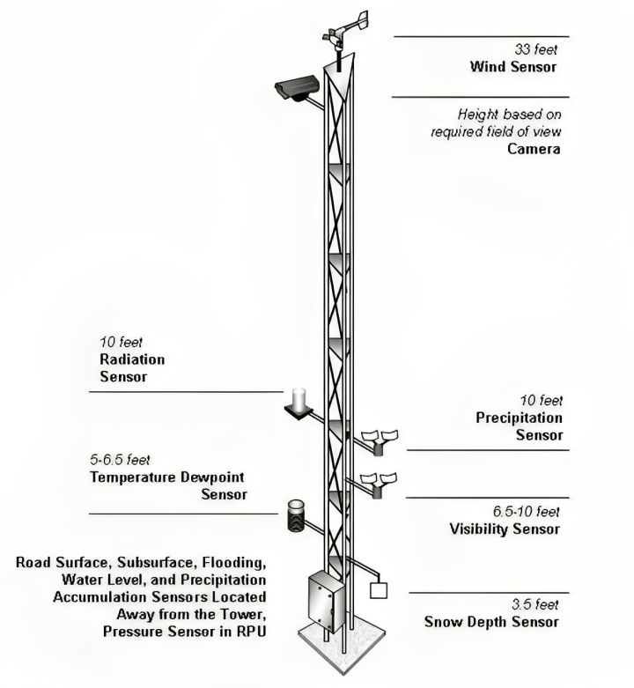

Figure ‎2‑11: Typical location of tower-based sensors for weather monitoring. [7]

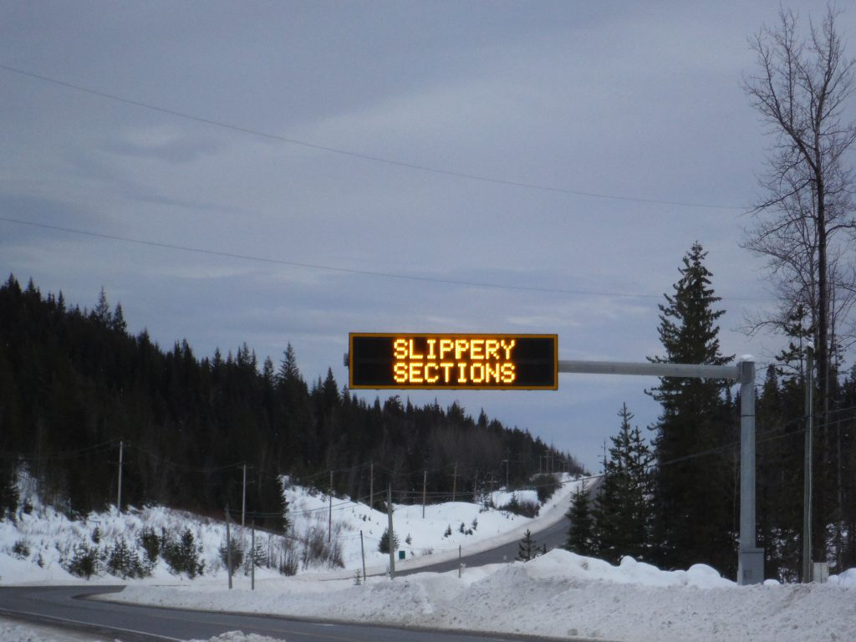

Figure ‎2‑12: Signage message to alert drivers of the road conditions.

A crucial component of this system is the use of variable message signs, which are strategically placed to inform drivers about current road conditions, weather updates, and potential hazards. These digital signs are directly linked to the data gathered by the RWIS, enabling them to display real-time information that is crucial for drivers. By employing these signs, the RWIS effectively communicates important alerts and advisories to motorists, allowing them to make informed decisions about their travel routes and driving behaviors. This immediate dissemination of information is particularly vital in areas prone to sudden weather changes or hazardous conditions, as it helps in reducing the likelihood of accidents and improving overall road safety. Figure ‎2‑12 illustrates an example of how a road weather monitoring system, integrated with these signage messages, operates to warn drivers and aid in proactive roadway management.

### System 4: Automatic Vehicle Identification and Toll Collection

The implementation of Automatic Vehicle Identification and Tolling (AVITC) Systems marks a significant advancement in managing traffic congestion, particularly in high-volume toll areas. Traditional toll booths, where vehicles must stop or slow down for manual transactions, significantly contribute to traffic build-up, reducing the overall flow and efficiency of transportation networks. By contrast, an automatic system streamlines the tolling process: it identifies vehicles using advanced technology such as RFID or license plate recognition, calculates the toll based on vehicle type or distance traveled, and automatically processes payments by deducting the fee from the driver's linked bank as shown in Figure ‎2‑13 . This automation not only accelerates the tolling process but also minimizes human error and reduces labor costs associated with manual toll collection.

Moreover, Automatic Vehicle Identification and Tolling Systems can dynamically adjust toll rates based on real-time traffic conditions, a concept known as congestion pricing. This strategy can effectively manage road usage, encouraging drivers to travel during off-peak hours or use alternative routes, thus alleviating congestion during rush hours. Additionally, the data collected from these systems can provide valuable insights for urban planners and policymakers in designing more efficient transportation infrastructures and making informed decisions about traffic management. The cumulative effect of these benefits extends beyond mere convenience; it promotes a more sustainable and environmentally friendly approach to road usage by reducing idle times and associated emissions, contributing significantly to the overall improvement of traffic flow and urban mobility.

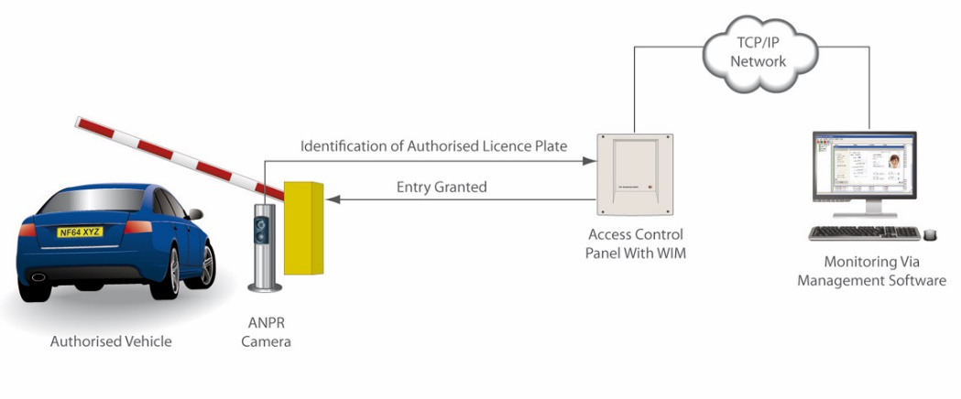

Figure ‑: Automatic number plate recognition system. [8]

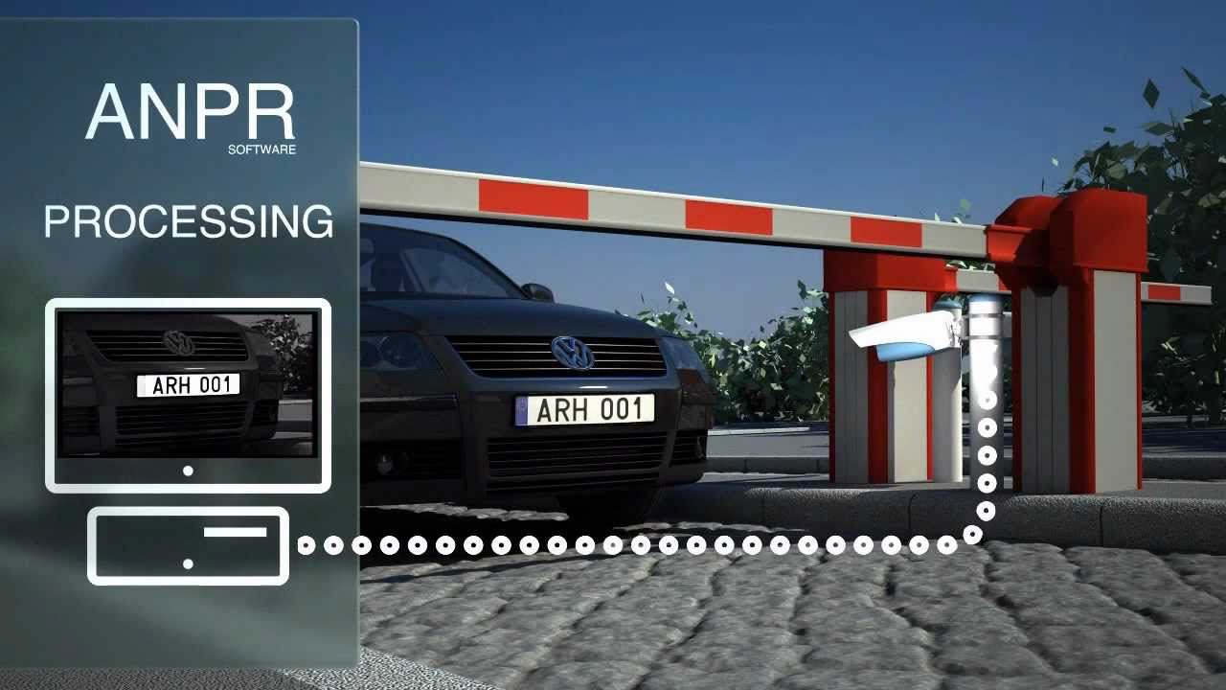

Figure ‑: Automatic number plate recognition system. [9]

The Automatic Number Plate Recognition (ANPR) system is a sophisticated technology that uses optical character recognition to read vehicle registration plates. This technology is widely employed in various applications, such as traffic enforcement, toll collection, and access control to secure areas as in Figure ‎2‑14. These systems can process information in real-time, allowing for immediate identification and verification of vehicles. This capability is particularly useful for law enforcement agencies in monitoring and managing traffic, identifying stolen or unregistered vehicles, and enforcing traffic rules as shown in Figure ‎2‑15. Additionally, ANPR systems are integral in intelligent transportation systems, contributing to smoother traffic flow and enhanced road safety.

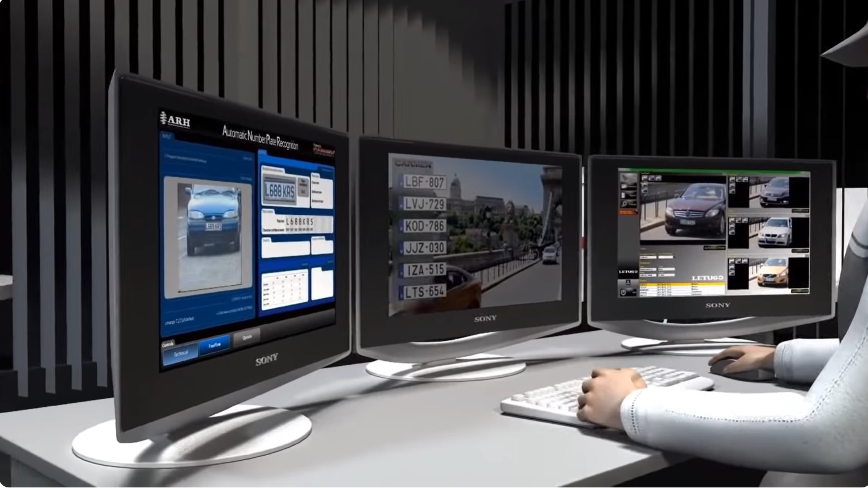

Figure ‑: Real-time monitoring of passing vehicles. [9]

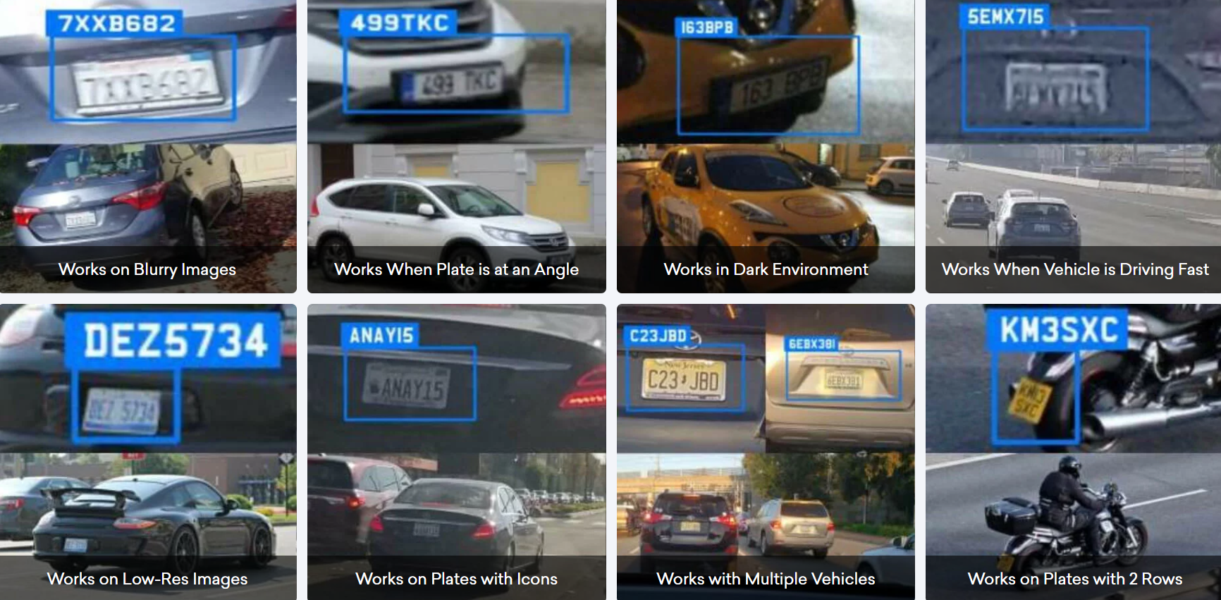

Figure ‑: Automatic number plate recognition under different conditions. [10]

Environmental conditions are never ideal, considering factors such as weather, time of day, regional variations in number plates, and the varying speeds of vehicles. Number plates can undergo bending, crumpling, and partial obstruction, while the challenge remains for operators to position high-quality cameras at an optimal angle in precisely the right location. Despite these challenges, accurate number plate data is essential. Automatic Number Plate Recognition (ANPR) technology is purposefully designed to address these challenges by using high-speed cameras and advanced software that can capture and analyze images of vehicle plates, ensuring definitively accurate data capture as shown in Figure ‎2‑16. This technology is utilized not only by government, police, and security services for community security globally but also finds application in a diverse array of businesses, including toll plazas, gated communities, weigh systems, areas with limited visibility due to snow, and even in drone operations. The advanced nature of ANPR software is exemplified by its trusted use in car wash businesses, where it effectively cuts through dirt and grime to ensure precise license plate capture.

**Table ‎2‑1: Vehicle Passed Away from Toll Booth in 1 year.** [11]

|  |  |  |
| --- | --- | --- |
| **Vehicle** | **Days** | **Toll Booth** |
| 100 | 1 | 1 |
| 36,000 | 30 $×$ 12 | 1 |
| 3,600,000 | 30 $×$ 12 | 100 |

Suppose in, if there are 100 manual toll-taxes system and every day 100 vehicles cross through each system, then No. of vehicles that pass through one system yearly = 100 x 30 x 12 = 36,000. No. of vehicles that pass through 100 systems yearly =100 x 36,000 = 36,00,000. And each car waits on average everyday 1 min at the toll booth. Assuming cost of 1-liter of fuel = 0.88 USD then total cost of fuel consumed by 3,600,000 vehicles = 0.88 x 3,600,000 = 3,168,000 USD.

The above is the money wastage under the consideration that the vehicle stops for 60 seconds at the toll booth, and 100 vehicles pass through the toll plaza each day and there are 100 toll plazas. These figures are all in minimum.

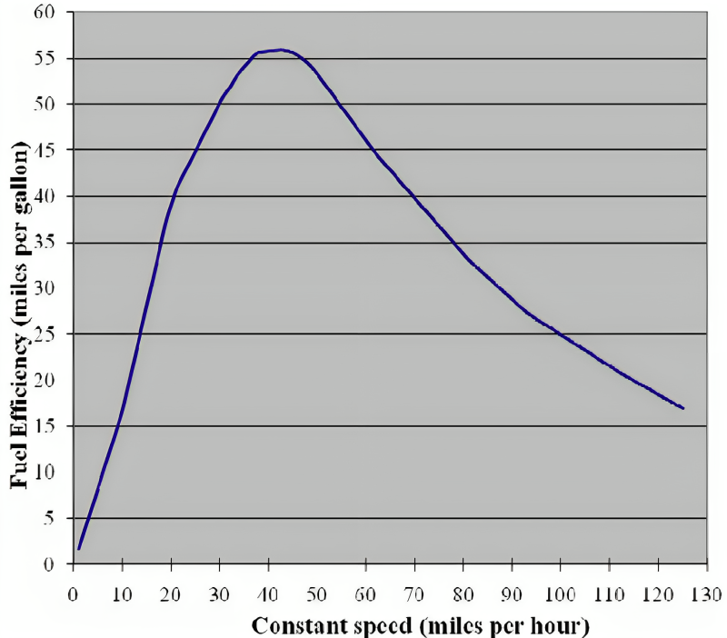

Figure ‑: Fuel consumption vs. speed. [12]

The data presented in Figure ‎2‑17 illustrates the relationship between vehicle speed and fuel consumption. It is evident from the graph that lower speeds lead to higher fuel consumption, a scenario commonly observed in situations of traffic congestion and prolonged waiting period. [12]

The CO2 calculation carried out assumes a petrol engine burning standard unleaded fuel with oxygen at stoichiometric (ideal) ratios. One liter of standard unleaded fuel burnt completely with oxygen yields 2.36kg of carbon dioxide. Using this ratio, CO2 emissions for an average passenger car were calculated for each speed (in 1mph intervals) from the average vehicle fuel consumption data. These values were then multiplied by the percentages of vehicles travelling at each speed on the three roads to be analyzed in order to determine the average CO2 produced per mile for all vehicles travelling on the road for that month (assuming that a constant speed is maintained over the mile covered). [12]

In terms of both fuel saved and CO2 emissions reduced. When a 50mph limit is enforced, the potential reduction in fuel consumption and emissions is likely to be up to 30% as shown in Table ‎**2‑2**, below. [12]

**Table ‎2‑2: Fuel Consumption, CO2 Emissions and Savings.** [12]

|  |  |  |  |
| --- | --- | --- | --- |
|  | **Unenforced 70mph limit** | **Enforced 70mph limit** | **Enforced 50mph limit** |
| **Fuel Consumption of ‘average car’ (MPG)** | 38.48 | 43.35 | 54.40 |
| **Annual fuel consumption (Gallons per mile)** | 699,459 | 620,268 | 493,156 |
| **Annual fuel saving (Gallons per mile)** | 0 | 79,190 | 206,303 |
| **CO2 Emissions (kg per vehicle per mile)** | 0.280 | 0.248 | 0.197 |
| **Annual CO2 Emissions (Metric tons per mile)** | 7,505 | 6,655 | 5,292 |
| **Annual CO2 Reduction (Metric tons per mile)** | 0 | 850 | 2,214 |
| **Percentage Saving (Fuel & CO2)** | 0% | 11.3% | 29.5% |

With increased variation in traffic speeds, as visible in the unenforced national speed limit speed profile, more individual acceleration and braking takes place, as faster drivers brake on approaching slower drivers then accelerate again. These actions lead to an increase in fuel consumption and emissions. In SPECS average speed enforcement areas, drivers tend to drive close to the speed limit with little variation in speed either throughout the area or between vehicles. This smoother driving leads to reduced fuel usage and CO2 emissions. Areas subject to peak period traffic congestion also benefit from SPECS average speed enforcement, as the reduction in speed variation delays the onset of traffic flow breakdown. This has been demonstrated by SPECS enforcement in roadworks reducing peak period congestion. A reduction in congestion will also have a positive effect in reducing fuel consumption and CO2 emissions. [12]

In summary, addressing traffic congestion contributes to lower fuel consumption and improved environmental sustainability. Vehicles stuck in traffic tend to burn more fuel while idling or moving slowly, resulting in increased greenhouse gas emissions, primarily carbon dioxide (CO2). By reducing congestion, vehicles spend less time idling and operate more efficiently, leading to decreased fuel consumption. Moreover, smoother traffic flow enhances overall fuel efficiency, as vehicles can maintain optimal speeds. Efforts to alleviate congestion often involve promoting alternative modes of transport, such as public transportation, cycling, and walking, which can lead to a modal shift away from private vehicles and contribute to reduced emissions. Additionally, the reduction in traffic congestion helps minimize the frequency of "cold starts," where engines operate inefficiently until reaching optimal temperature, further improving overall fuel efficiency and environmental impact.

### System 5: Lighting Control

Street lights account for a significant portion of energy consumption in cities and towns worldwide. The strategic control of street lighting plays a crucial role in energy conservation and sustainability worldwide. Modern street lighting systems, equipped with intelligent control mechanisms, can significantly reduce energy consumption without compromising public safety. By adjusting the operation ratio of lights, such as reducing the intensity or switching off lights during low-traffic hours, these systems can optimize energy usage effectively. The integration of advanced lighting controls, such as occupancy sensors and daylight harvesting controls, further optimizes energy usage. Occupancy sensors reduce or turn off lighting in unoccupied areas, while daylight harvesting controls adjust electric lighting based on natural light levels.

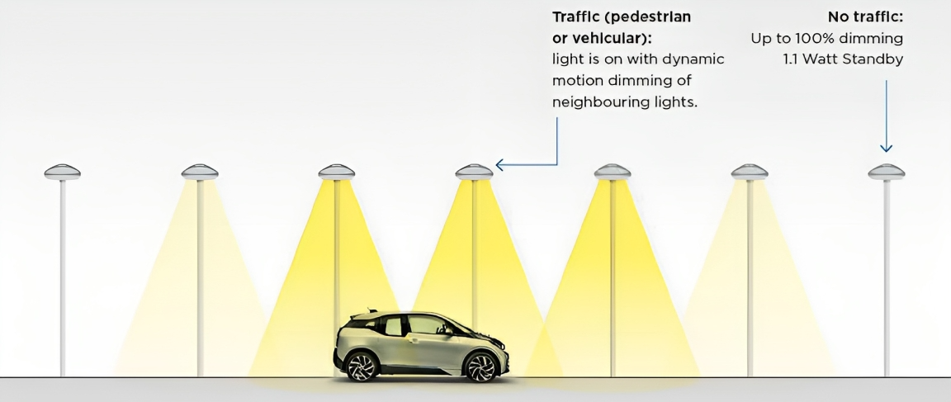

Figure ‑: Street lights control by targeted dimming of LED lights. [16]

Compared to normal LED street lighting you increase energy efficiency up to 90% with the intelligent lighting system. This extends the lifetime of the luminaires and reduces maintenance costs. The system can always be adapted to new conditions, so that a perfect illumination of the road is always guaranteed as shown in Figure ‎2‑18. Since the illumination of a street section is only increased as required, the light pollution can be considerably reduced [13].

Figure ‎2‑19 shows the general architecture of the Smart Street pilot site is located at the ENEA Casaccia R.C. (Rome): the system is a public street lighting line managed in an automatic (programmable) and manual ways. Thanks to the sensors that the system is equipped with, it is possible to program the switching of lights, according to the ephemeris tables (local sunrise and sunset), based on a pre-set and fixed timetable. The system is able to respond dynamically, due to the presence of smart cameras, to the traffic flow rate. The system is composed of streetlights; every unit has a ‘‘lamp assembly” composed by an IP Node, a LED driver, and a LED matrix lamp. Since each lamp has a unique IP address, it is possible to monitor the individual status and adjust the brightness by operating on the driver that has a specific interface. Several smart cameras provide all the traffic data information, as they are able to record not only the passage of a vehicle or a pedestrian, but also detect its type and speed. All the status information and electric power absorption data are then sent to a hub that takes care to send it to a remote computer system which, moreover, stores the critical data of all the street lamps at 15 min intervals; thanks to a software developed ad hoc, it is possible to run the reverse path to the controls in order to pilot the LED driver. It is therefore possible to receive the telemetry data of each single lamp and consequently send appropriate remote controls that can adjust the brightness from 100% up to the off state. [17]

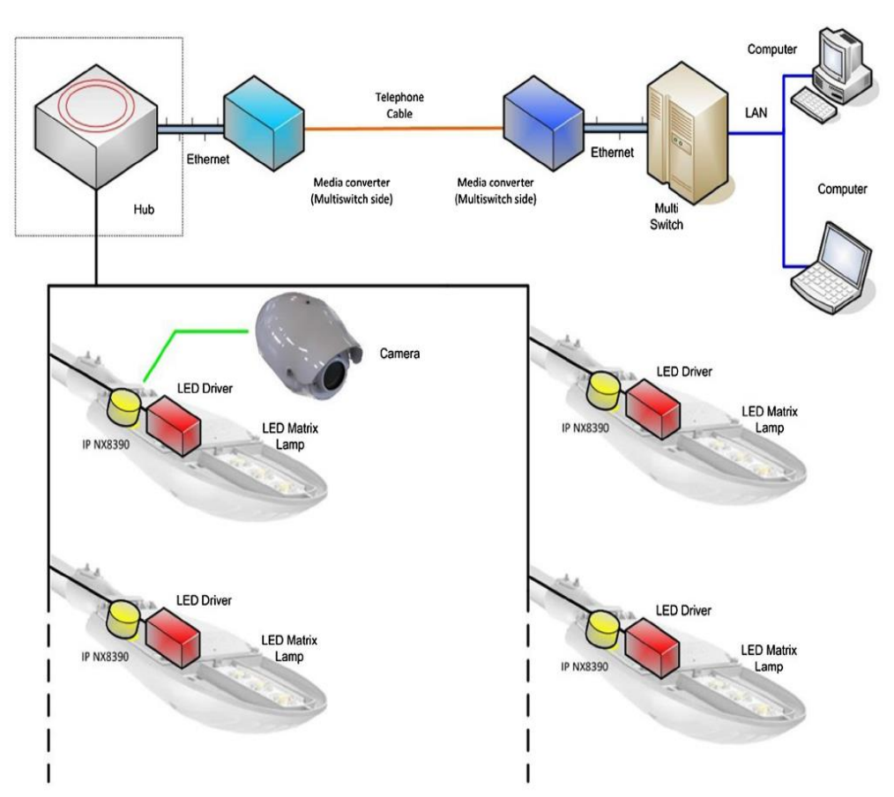

**Figure ‎2‑19: Smart street pilot site system general architecture.** [17]

Figure ‑: Smart and sustainable lighting benefits. [17]

Smart and sustainable lighting brings a host of benefits to urban environments as shown in Figure ‎2‑20. By integrating advanced technologies such as LED fixtures, sensors, and intelligent controls, cities can achieve significant energy savings, reduce environmental impact, and enhance overall efficiency. These systems allow for adaptive lighting, responding to real-time conditions and optimizing energy consumption. Moreover, smart lighting contributes to increased safety, improved visibility, and a reduction in light pollution, creating more sustainable and livable urban spaces. The long-term advantages include cost savings, improved quality of life, and a positive impact on the environment, making smart and sustainable lighting a crucial element in modern urban planning.

Chapter Three

# EXPERMIENT AND RESULTS

In the experimental phase, individual systems and output actuators were assessed on a small scale to determine their efficacy and reliability. The experiment involved a series of controlled tests, each designed to evaluate specific functionalities and response times of the systems under varying conditions. The results from these tests were crucial in understanding the performance capabilities and limitations of the individual components. Output actuators, which are essential in executing the system's commands, were closely monitored for their precision and speed. The data gathered from these experiments provided valuable insights into the overall system integration, highlighting areas where performance could be optimized. The success of these small-scale tests was a vital step towards scaling up the systems for broader applications, ensuring that they operate efficiently and effectively in real-world scenarios.

## System 1: WIM: Intelligent Truck Weighing Management System

### Load Cell and HX711 Amplifier

**Description:**

A load cell converts a force into an electrical signal that can be measured. The electrical signal changes proportionally to the force applied.

#### Load Cell Circuit Diagram

Strain gauge load cells are composed of a metal bar with attached strain gauges (under the white glue in the picture below). A strain gauge is an electrical sensor that measures force or strain on an object. The resistance of the strain gauges varies when an external force is applied to an object, which results in a deformation of the object’s shape (in this case, the metal bar). The strain gauge resistance is proportional to the load applied, which allows us to calculate the weight of objects. Usually, load cells have four strain gauges hooked up in a Wheatstone bridge that allow us to get accurate resistance measurements as shown below in Figure ‎3‑1.

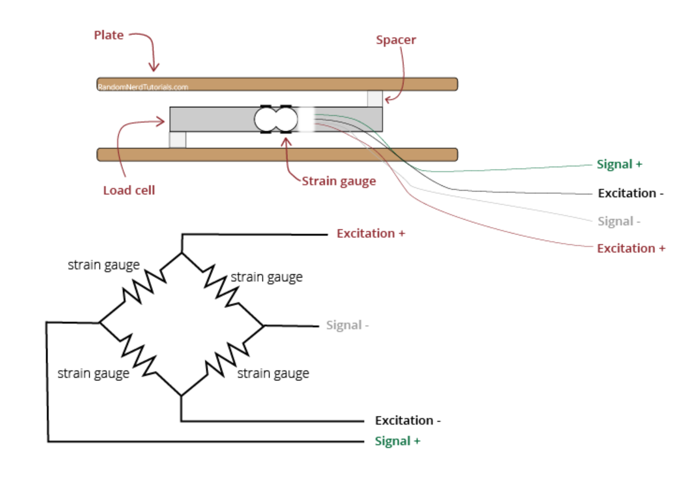

Figure ‎3‑1: Load Cell Circuit Diagram. [20]

The incorporation of load cell weight sensors in our system serves as a pivotal element for precise weight measurement. Load cells are integral in converting mechanical force into electrical signals, enabling accurate and reliable weight readings. Their application spans various industries, from industrial scales to medical devices, offering a versatile solution for weight measurement needs. For more comprehensive details, the following Table ‎3‑1 provide an in-depth overview of the specifications and features of the load cell weight sensors used in our system.

**Table ‎3‑1: Comparison between load cell weight sensor and bathroom scale weight sensor**

| **Sensor** | **Load Cell Weight Sensor** | **Bathroom Scale Weight Sensor** |
| --- | --- | --- |
| Measurement  Type | Force/Weight | Force/Weight |
| Accuracy | Highly accurate (±0.1% or better) | Low accuracy (±5% or more) |
| Linearity | High | Moderate |
| Hysteresis | Low | Moderate |
| Measurement  Range | Wide (kg to tons) | Narrow (person weight only) |
| Temperature  Effect | Minimal | Significant |
| Humidity Effect | Minimal | Significant |
| Applications | Industrial weighing, shipping, precision measurement | Home scales, fitness tracking |
| Construction | Uses strain gauges to measure  compression | Uses strain gauges to measure  compression |
| Output | Analog voltage or digital from module | Analog only |
| Durability | Rugged and withstands  vibration/overloading | Not durable, can break under  stress |
| Cost | Moderate-high depending on capacity and accuracy | Low |

**Table ‎3‑2: 20 KG Load Cell Weight Sensor Specifications.** [21]

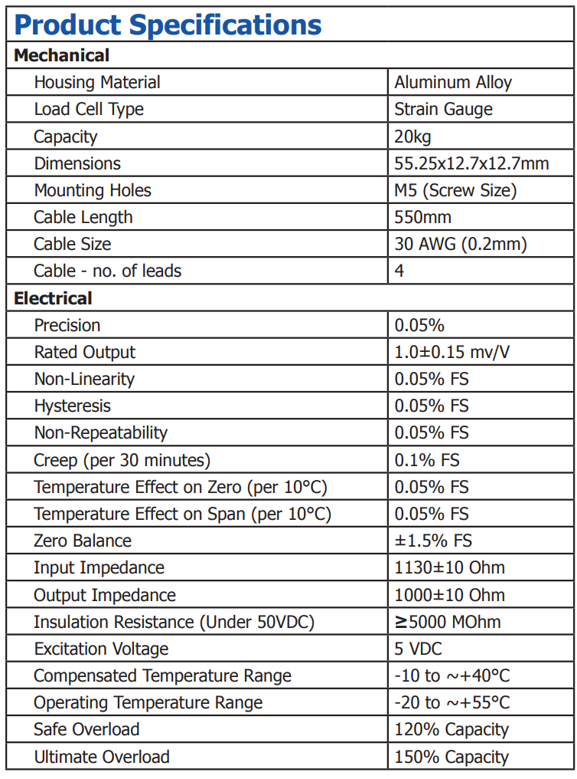

#### ****Load Cell Weight Sensor Wiring****

A load cell is an essential component in weight measurement systems, commonly used in scales, industrial machinery, and testing equipment. It operates by converting mechanical force into an electrical signal. When wiring a load cell weight sensor, it's crucial to correctly connect the wires to ensure accurate readings. Typically, a load cell has four wires: two for providing the excitation voltage (usually red and black) and two for measuring the output signal (commonly green and white). The red wire connects to the positive excitation voltage, while the black wire connects to the negative. The green wire is usually the positive signal, and the white wire is the negative signal. Additionally, some load cells have a shield wire to minimize electrical noise. Proper calibration after wiring is essential for precise weight measurements. As shown in Figure ‎3‑2.

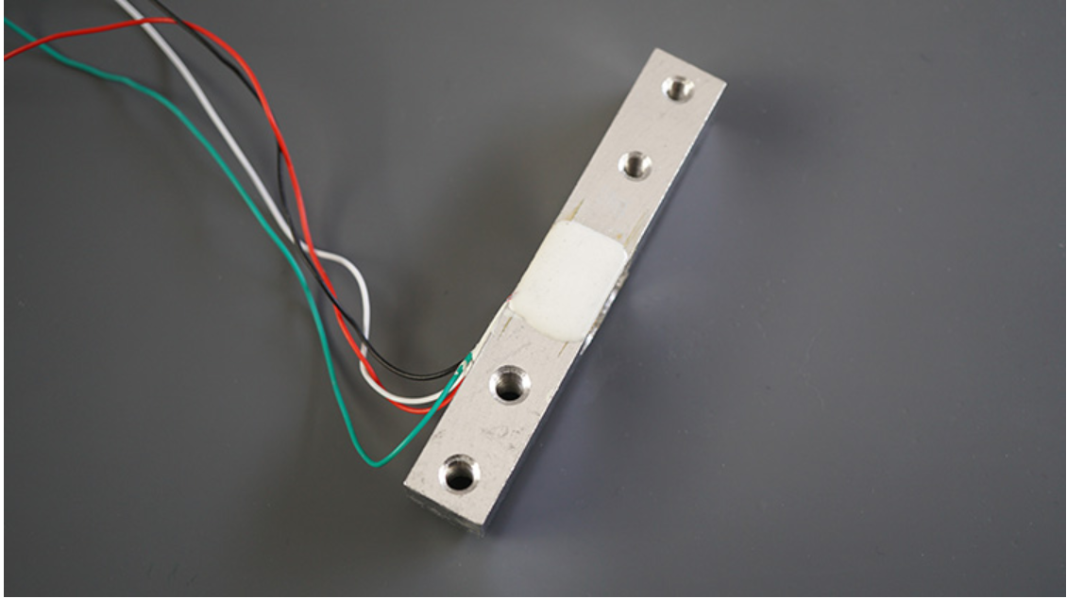

Figure ‎3‑2: 20 KG load cell weight sensor. [20]

The wires coming from the load cell usually have the following colors:

* Red: VCC (E+)
* Black: GND (E-)
* White: Output – (A-)
* Green: Output + (A+)

#### Working principle of load cell weight sensor

In a load cell, strain gauges acting as variable resistors are attached to a beam that bends under an applied load. When no load is applied, the resistances in all the strain gauges remain equal and balanced. This results in no voltage difference across the Wheatstone bridge output as illustrated in Figure ‎3‑3.

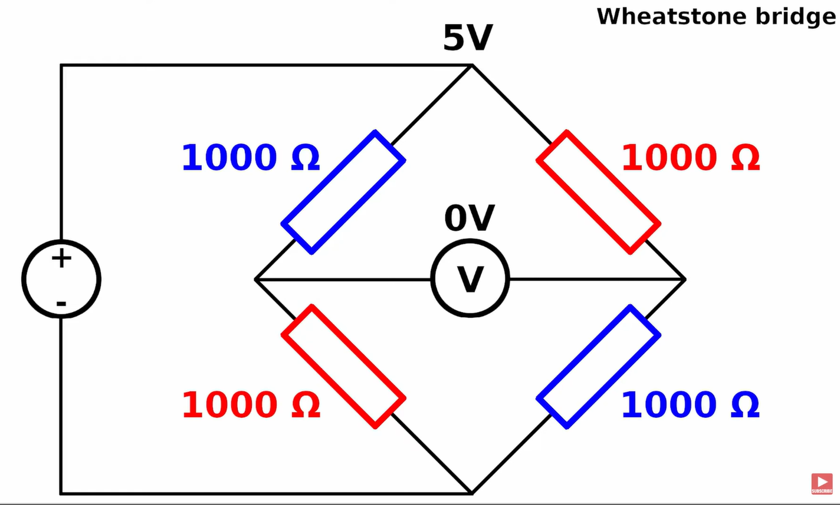

Figure ‎3‑3: Voltage difference of load cell when no weight applied. [20]

However, when a load is applied, it causes the beam to bend slightly. This bending causes the strain gauges on the top surface to become compressed and their resistances increase slightly. At the same time, the gauges on the bottom surface become stretched and their resistances decrease slightly.

This imbalance in the resistances across the Wheatstone bridge legs produces a voltage difference at the output. This output voltage is directly proportional to the amount of bending/load applied and provides a measure of the applied force or weight as illustrated in Figure ‎3‑4.

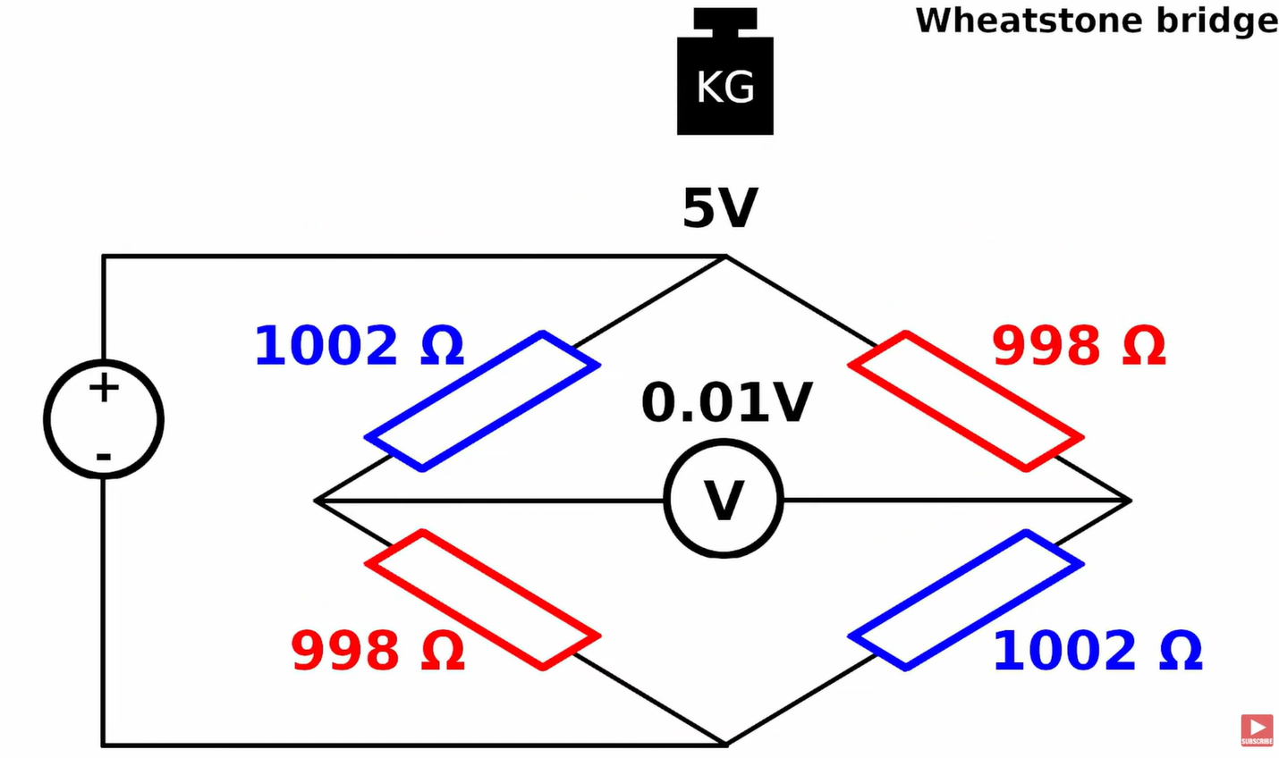

Figure ‎3‑4: Voltage difference of Wheatstone bridge when weight applied. [20]

#### Connecting the Load Cell to the HX711 Module and Arduino

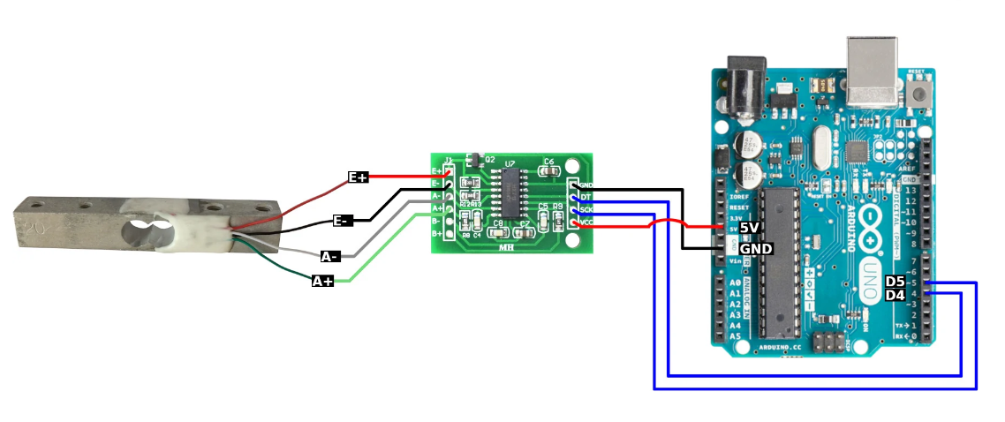

Figure ‎3‑5: Connections of load cell to the HX711 module and Arduino. [20]

Connecting a load cell directly to a microcontroller without an amplifier, such as the HX711, poses several challenges. Load cells generate very small electrical signals in the order of millivolts, which are difficult for microcontrollers to accurately measure and process. These weak signals are susceptible to noise and interference, resulting in inaccurate weight readings.

Load cells also generally require an excitation voltage (typically 5V) to power their internal strain gauges. Microcontrollers often lack the capability to provide this excitation voltage, making it necessary to use an external amplifier like the HX711 that can generate the required voltage.

We need to create a strain between the opposing ends of the load cell. The easiest way to do that is to attach it between two boards. The bottom board holds scale in place, and the top board is the weighing plate. Making sure we put some spacers between the board and the load cell, so there is room for deformation as in Figure ‎3‑6.

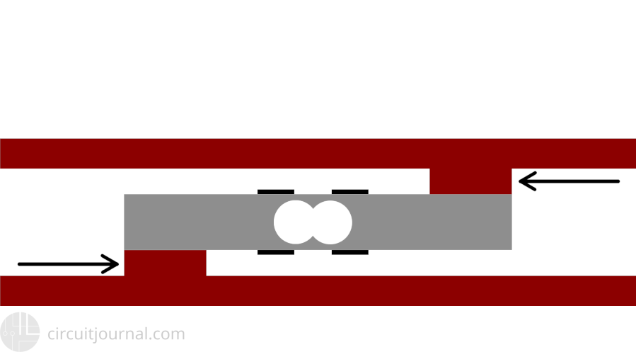

Figure ‎3‑6: No force applied. [23]

When you apply force to the load cell, two of the strain gauges will compress (red) while the other two will stretch (blue) shown in Figure ‎3‑7.

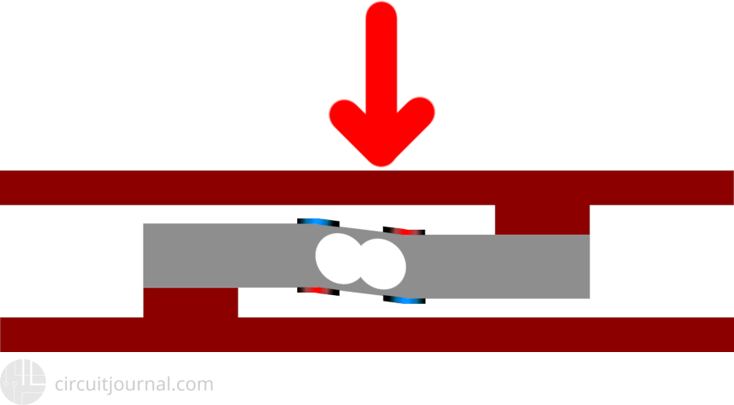

Figure ‎3‑7: Force applied. [23]

#### Load Cell with HX711 Amplifier: Proteus Circuit Diagram

Now that we have completely understood how load cell with HX711 amplifier works, we can connect all the required wires to Arduino and write the code to get weight measurement for the vehicle weighing system. The following figures show the circuit diagram for interfacing the load cell with Arduino using Proteus 8 Professional as in Figure ‎3‑8.

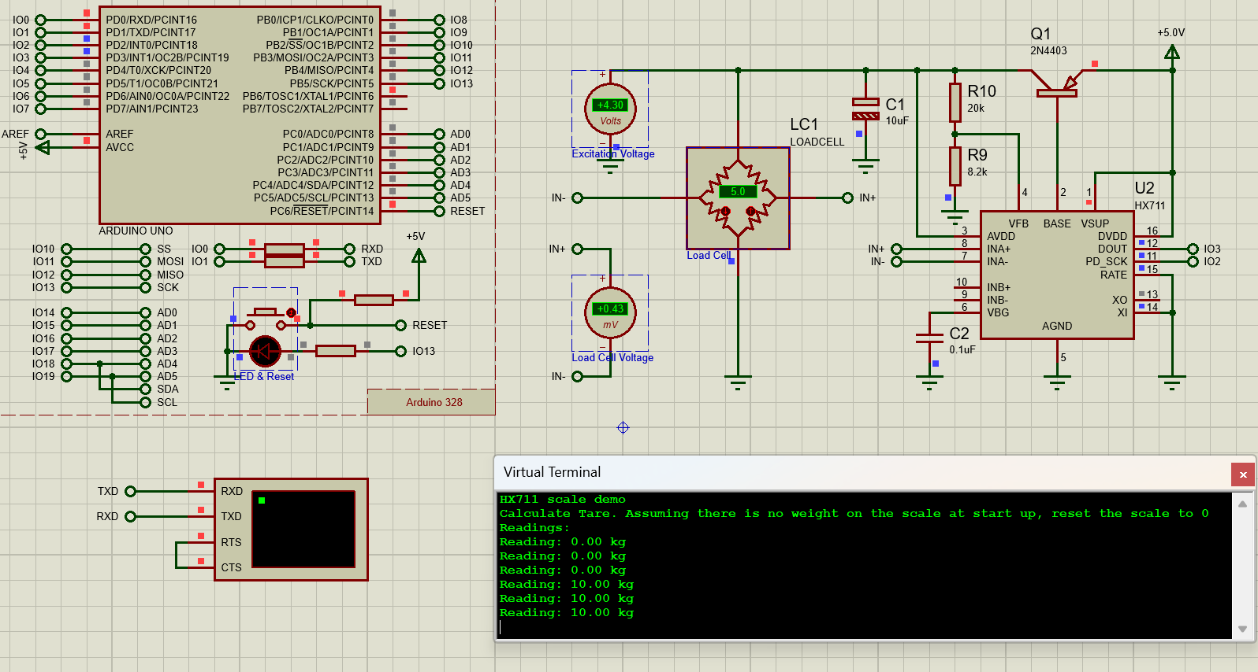

Figure ‎3‑8: Sample project of load cell with HX711 amplifier on Proteus using Arduino.

#### Hardware Implementation

The hardware implementation of a weighing system beneath the road surface in a tolling system for trucks is crucial for ensuring fairness and expediting the toll collection process as shown in Figure ‎3‑9. The load cell accurately measures the weight of passing trucks in real-time. This data is seamlessly integrated into an automated system that calculates the applicable toll fee based on the load. The load cell's placement beneath the road surface ensures accurate weight measurements and minimizes the impact on traffic flow. The automated system, utilizing this load cell data, enables a fair and consistent application of toll fees, eliminating the potential for human error or bias. This technology enhances the overall efficiency of toll collection, contributing to a more fluid and expedited traffic experience while maintaining fairness in the fee calculation process as shown in Figure ‎3‑10 and Figure ‎3‑11.

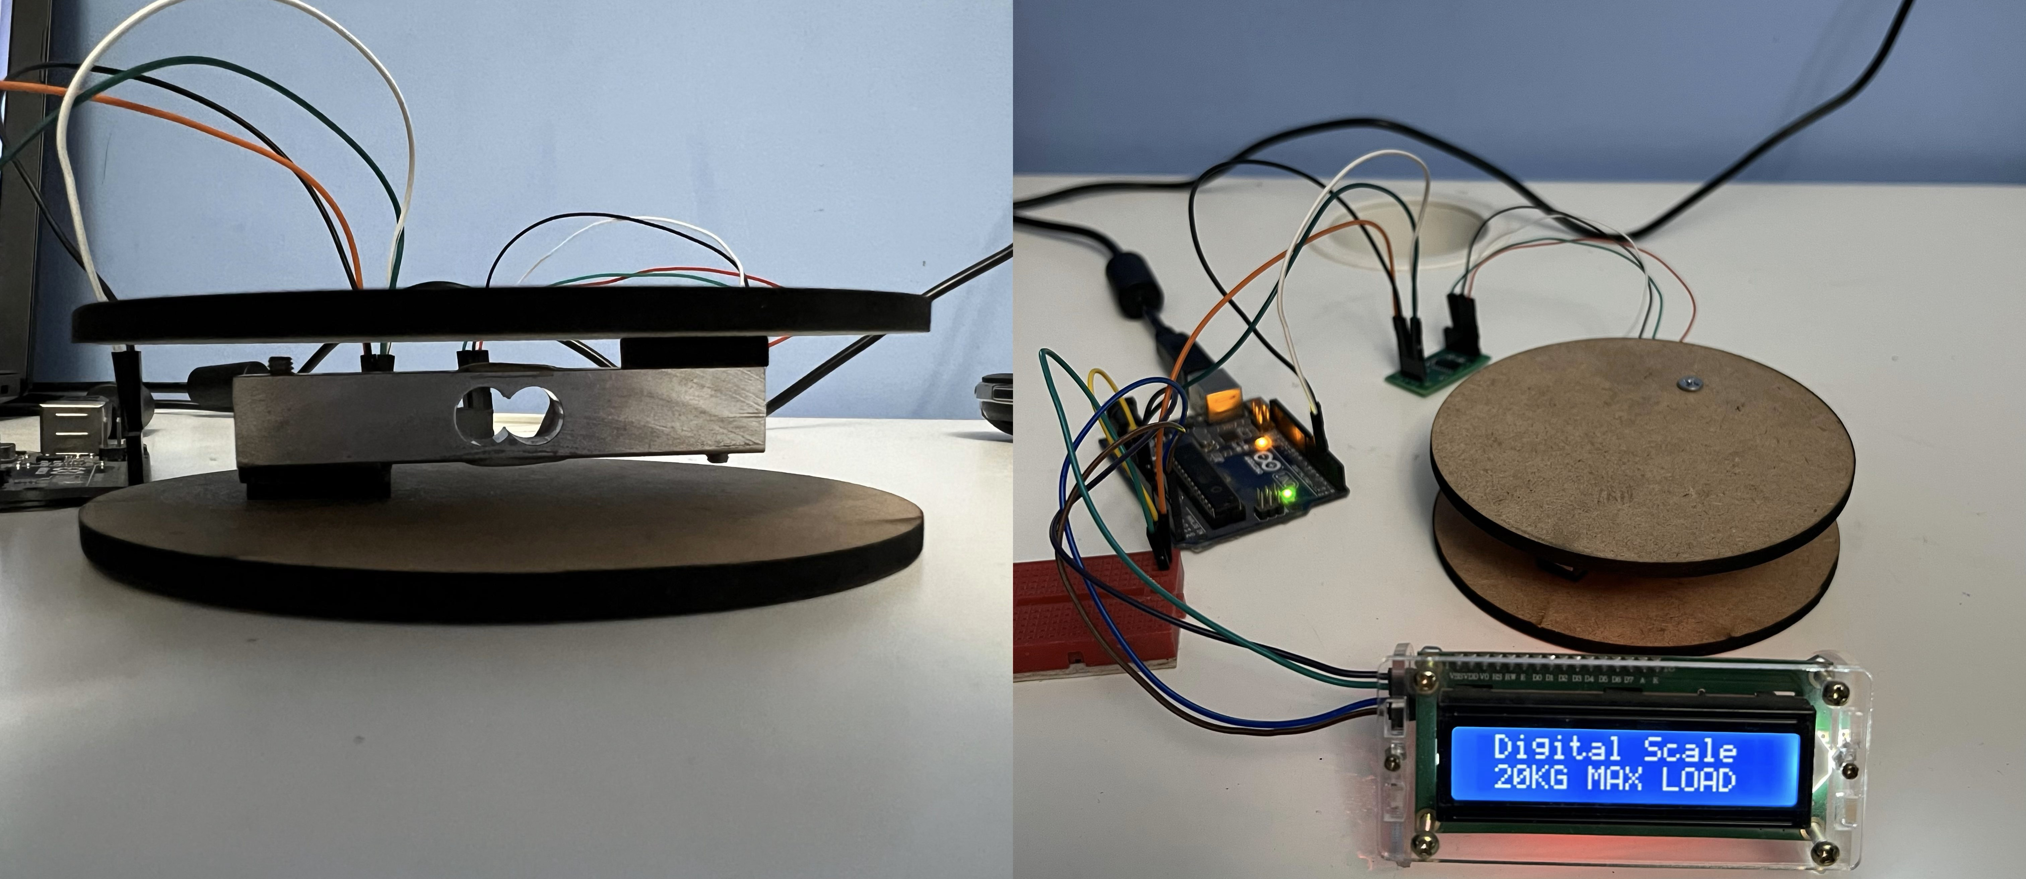

Figure ‎3‑9: Intelligent truck weighing management system.

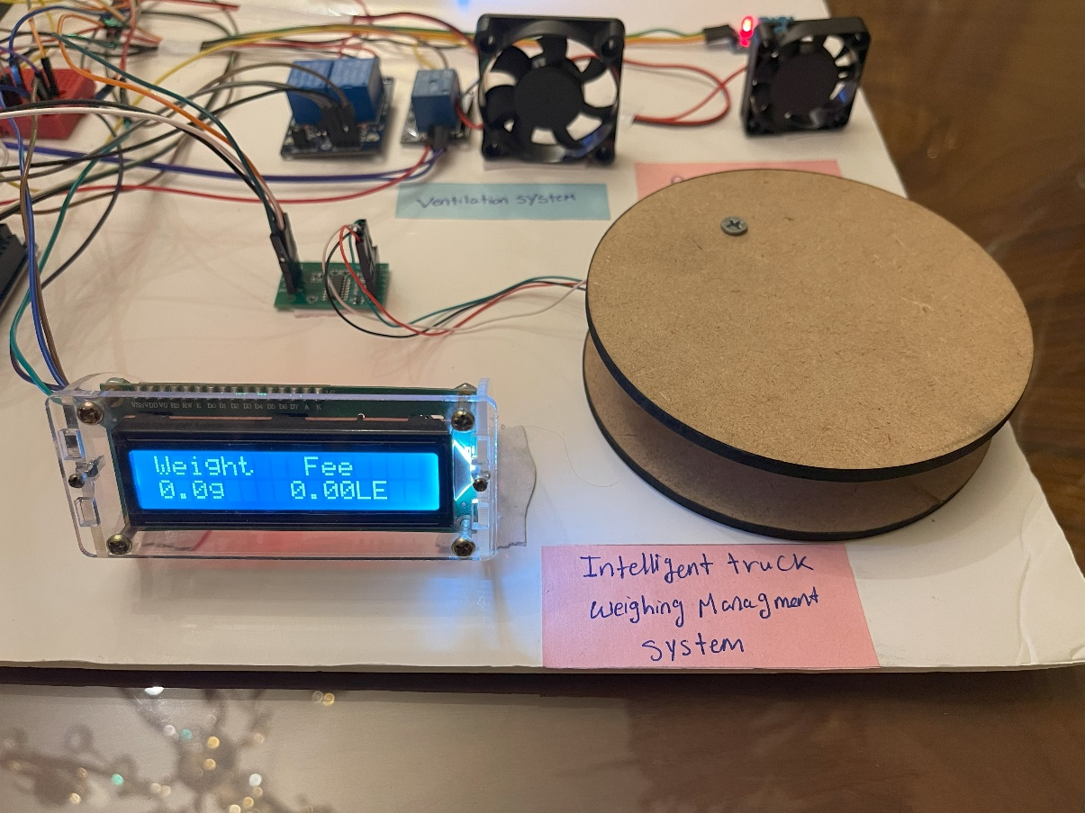

Figure ‑: No load.

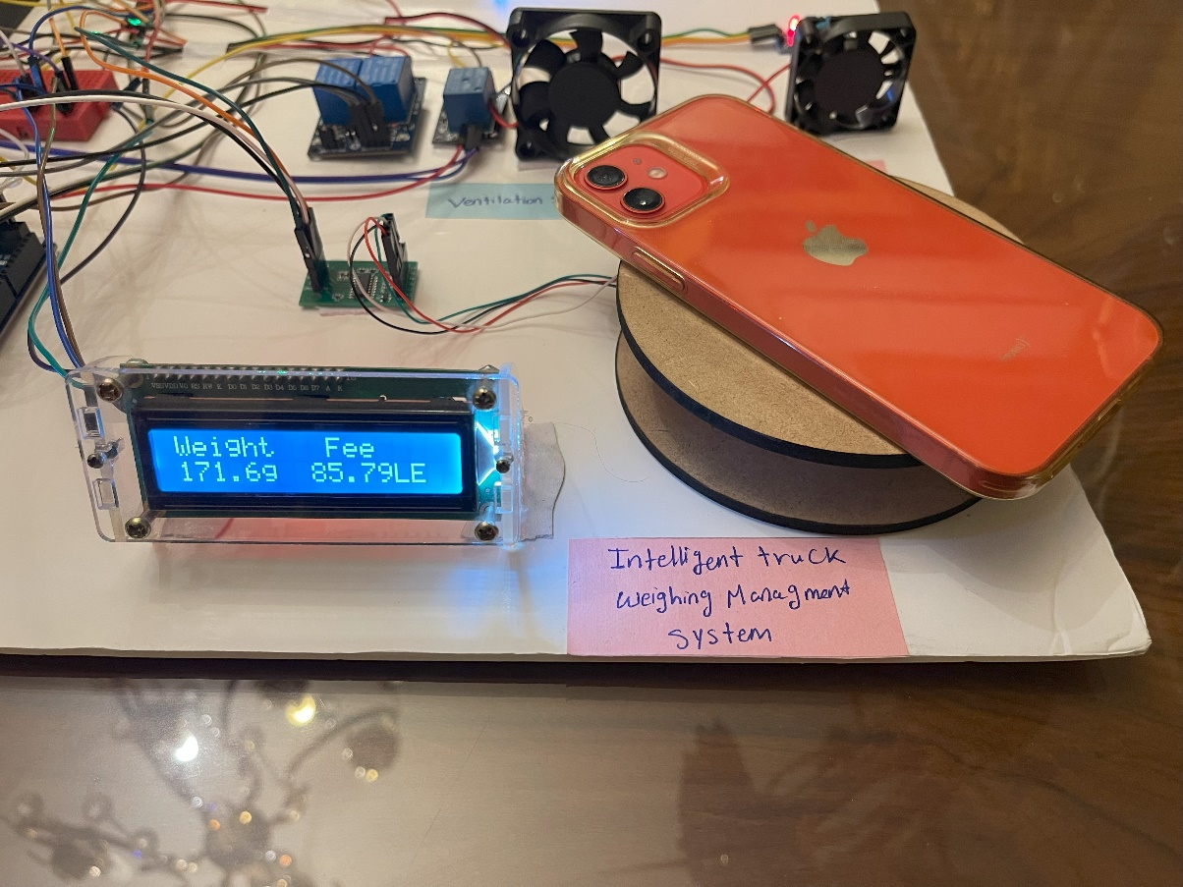

Figure ‑: Calculated fee for the applied load.

## System 2: Fire Suppression

### Flame Sensor Module LM393

**Description:**  
A flame sensor is a type of detector that is used to detect and react to the occurrence of a fire or flame. It frequently responds faster and more precisely than a heat or smoke sensor because of the mechanisms it utilizes to detect the flame. These sensors are used in safety equipment to maintain offices, homes, or stores safe from fire accidents.

#### Flame Sensor Module Circuit Diagram

The schematic diagram for the flame sensor module is given below. As mentioned earlier, the board has a very low component count. The main components are the IR photodiode and the comparator circuit as shown in Figure ‎3‑12.

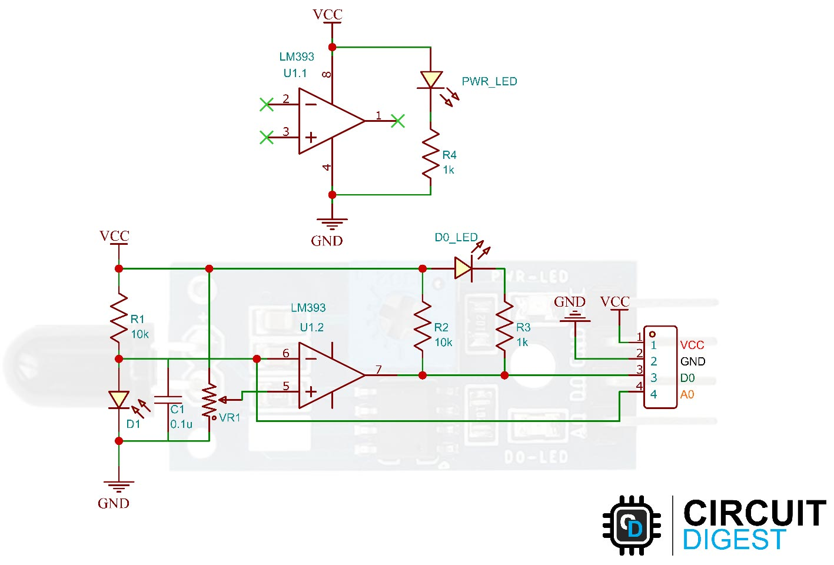

Figure ‎3‑12: Flame Sensor Module Circuit Diagram. [26]

#### Why Flame Sensor Module LM393?

The selection of the Flame Sensor Module LM393 for the implementation of the fire suppression system is grounded in a thoughtful consideration of various factors. Firstly, the sensor's specifications align with the requirements of the fire suppression system, ensuring its compatibility and effectiveness in detecting flames. Additionally, the LM393 module proves to be a cost-effective solution, offering functionality at a reasonable price point. Its widespread availability in the market further contributes to the feasibility of integration into the system. Functionality is a key determinant, and the LM393 module's capability to reliably detect flames enhances the overall efficacy of the fire suppression system as shown in **Table ‎3‑3** and **Table ‎3‑4** below.

**Table ‎3‑3: Selection criteria of flame sensor module LM393.**

| **Sensor** | **Reason for Selection/Rejection** |
| --- | --- |
| TMP35 and  LM35 | Rejected as these only function with electronic devices using transfer  equations to calculate the voltage. Unable to directly detect heat. |
| MLX90614  Infrared  Thermometer | Potential for direct heat measurement but library support lacking on  Proteus 8 Professional. |
| **Flame Sensor with LM393** | **Selected as it enables direct heat/flame detection.**  **Libraries available to simulate on Proteus 8 Professional, allowing**  **testing before procurement.** |

**Table ‎3‑4: Flame sensor module specifications.**

| **Specification** | **Description** |
| --- | --- |
| Operating Voltage | 3.3V to 5V |
| Operating Current | 15 mA |
| Comparator Chip | LM393 |
| Sensor Type | YG1006 Phototransistor |
| Sensitivity | Adjustable by potentiometer |
| Output Type | Digital o/p or Digital & Analog output |
| Red LED | For power |
| Green LED | For output |
| Spectrum Range | 760 nm to 1100 nm |
| Detection Angle | 0 to 60 degrees |
| Operating Temperature | -25℃ to 85℃ |
| Range | Accurate up to about 1m |

#### ****Flame Sensor Module Parts****

The flame sensor module has only very few components, which include an IR photodiode, an LM393 comparator IC, and some complimentary passive components. The power LED will light up when the module is powered and the D0 LED will turn off, when a flame is detected. The sensitivity can be adjusted with the trimmer resistor onboard as in Figure ‎3‑13.

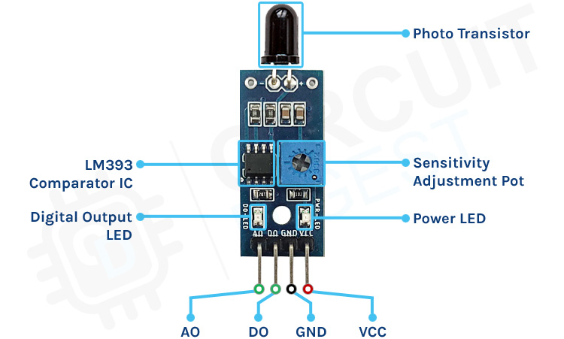

Figure ‎3‑13: Pinsfunctions. [26]

* VCC: 5V Power supply
* GND: Ground
* DO: Digital Output
* AO: Analog Output

#### ****How Does the Flame Sensor Module Works?****

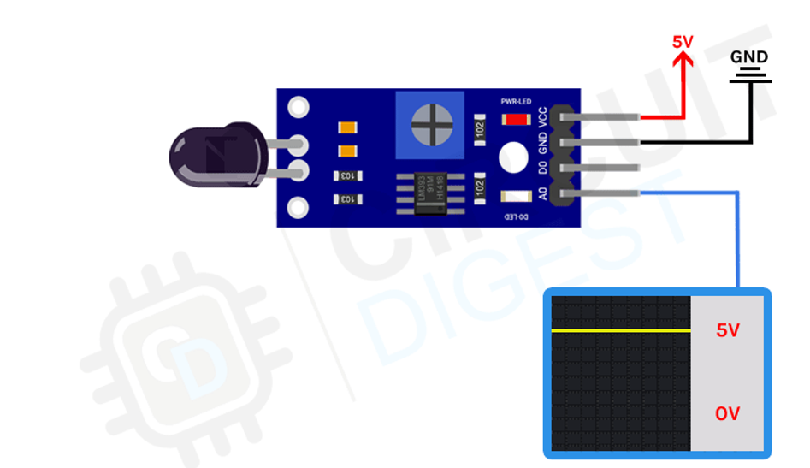

Figure ‎3‑14: Flame sensor module output when no fire in range. [26]

The working of the flame sensor module is simple. The theory behind it is that a hot body will emit infrared radiation. And for a flame or fire, this radiation will be high. We will detect this IR radiation using an infrared photodiode. The conductivity of the photodiode will vary depending on the IR radiation it detects. We use an LM393 to compare this radiation and when a threshold value is reached the digital output is changed as shown in Figure ‎3‑14 scenario which shows the state when no fire is detected, and Figure ‎3‑15 depicts the condition when a fire is detected..

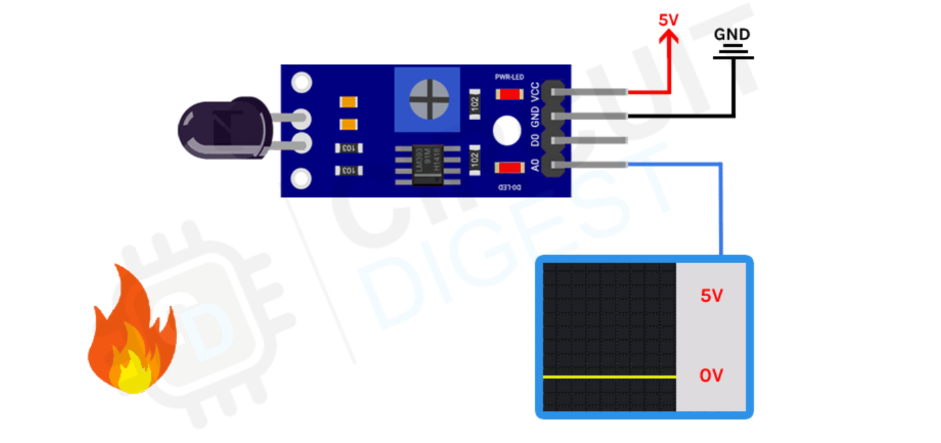

Figure ‎3‑15: Flame sensor module output when fire in range. [26]

#### ****Flame Sensor Interfacing with Arduino: Proteus Circuit Diagram****

Now that we have completely understood how a Flame Sensor works, the following figures show the circuit diagram for interfacing the flame sensor module with Arduino Mega using Proteus as in Figure ‎3‑16 when fire condition is false and Figure ‎3‑17 when fire condition true.

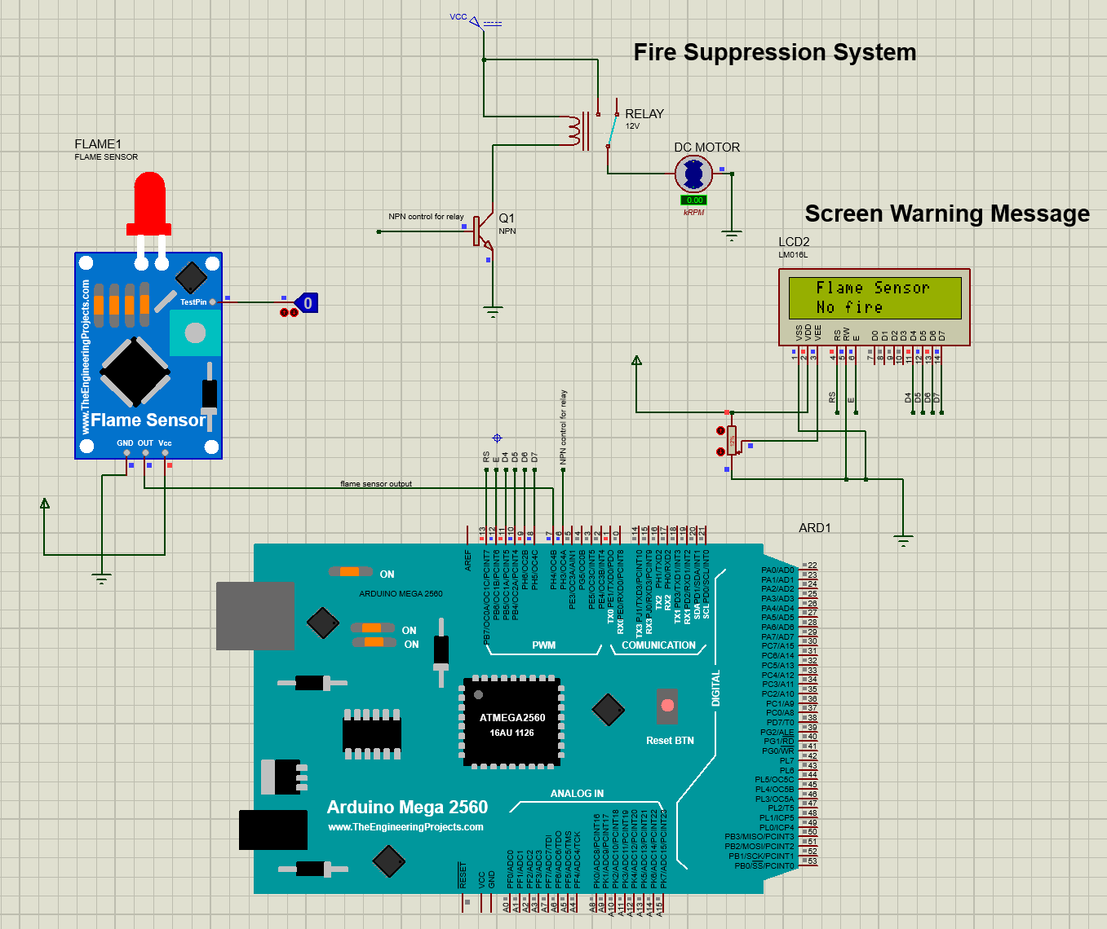

Figure ‎3‑16: Interfacing flame sensor on proteus with test pin is low.

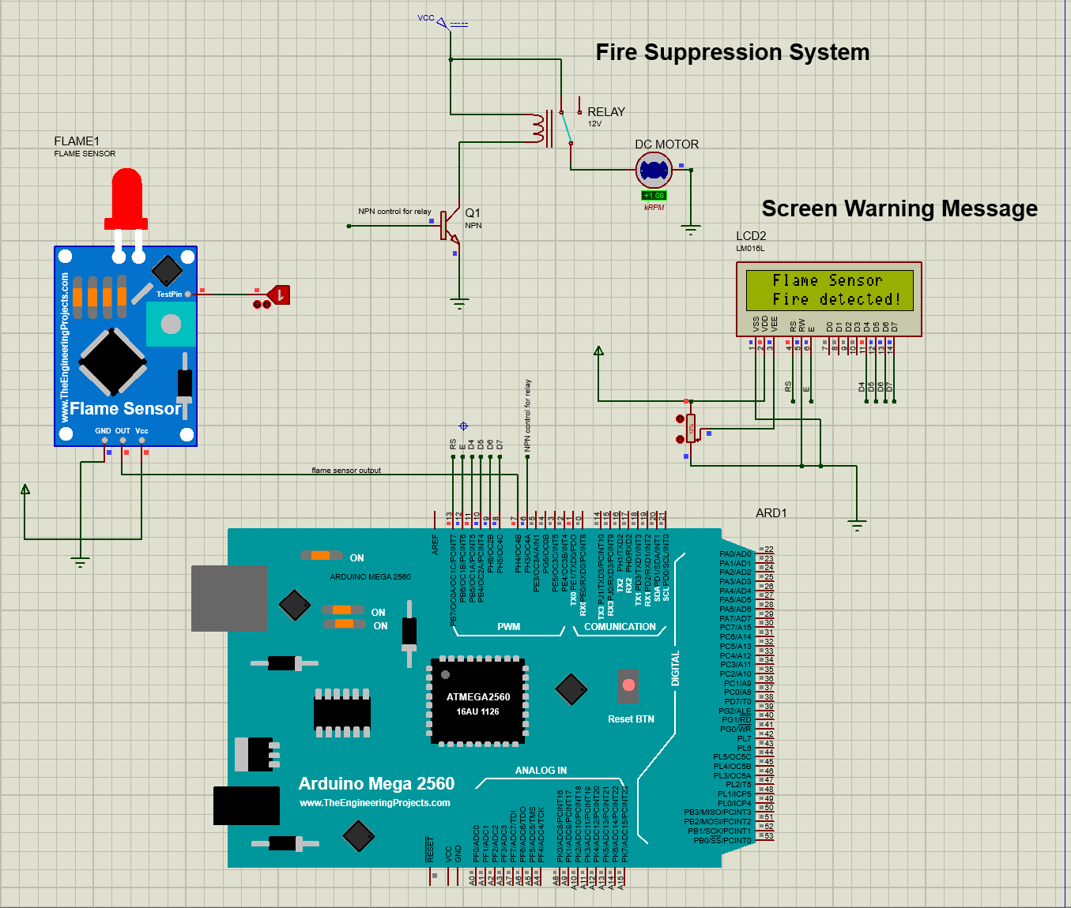

Figure ‑: Interfacing flame sensor on proteus with test pin is high.

**Advantages:**

* High-speed response
* Resistant to fake alarms
* Long detection distance, environmental adaptability is good & high reliability

**Applications:**

* A flame-sensor is mainly used to detect & react to the occurrence of a flame/fire
* Flame sensors are used in fire alarms, fire detection, drying systems, firefighting robot, industrial heating, hydrogen stations, domestic heating systems, industrial gas turbines, gas-powered cooking devices, etc.
* These are used in MDF factories, pharmaceuticals, fume cupboards, coal handling, spray booths, nuclear industry, fabrication of metal, clothing dryers, aircraft hangars, gas fueled cookers, domestic heating systems, heating & drying systems in industries, generators & storage tanks.

#### Hardware Implementation

The hardware implementation of a fire suppression system within a tunnel integrates flame sensors to swiftly respond to fire incidents. When the flame sensor detects the presence of fire, it triggers the activation of water pumps, initiating an immediate response to extinguish the flames and prevent further escalation. Simultaneously, the system communicates with external LCD displays positioned outside the tunnel, projecting warning messages to incoming vehicles as in Figure ‎3‑18. This serves as a crucial precautionary measure to prevent potential chain reactions and ensure the safety of approaching traffic. In the absence of fire, the system remains in an idle state, continuously monitoring the tunnel environment as in Figure ‎3‑19. This proactive hardware configuration emphasizes the system's responsiveness in the face of emergencies while also maintaining a vigilant stance during regular operational periods, contributing to overall tunnel safety and fire prevention.

Water pump

Fire applied

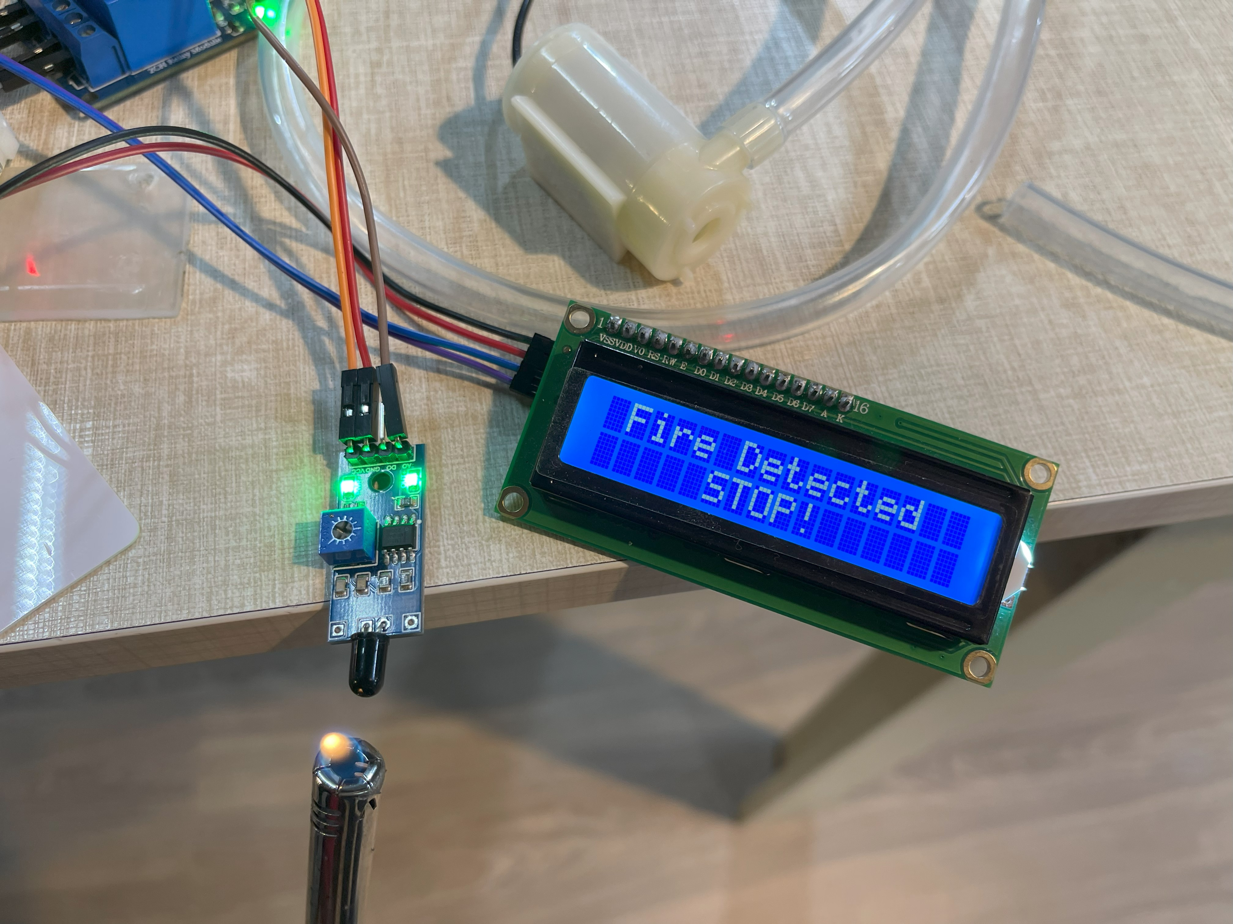

Figure ‎3‑18: When fire is detected, warning message is displayed, and the water pump activates.

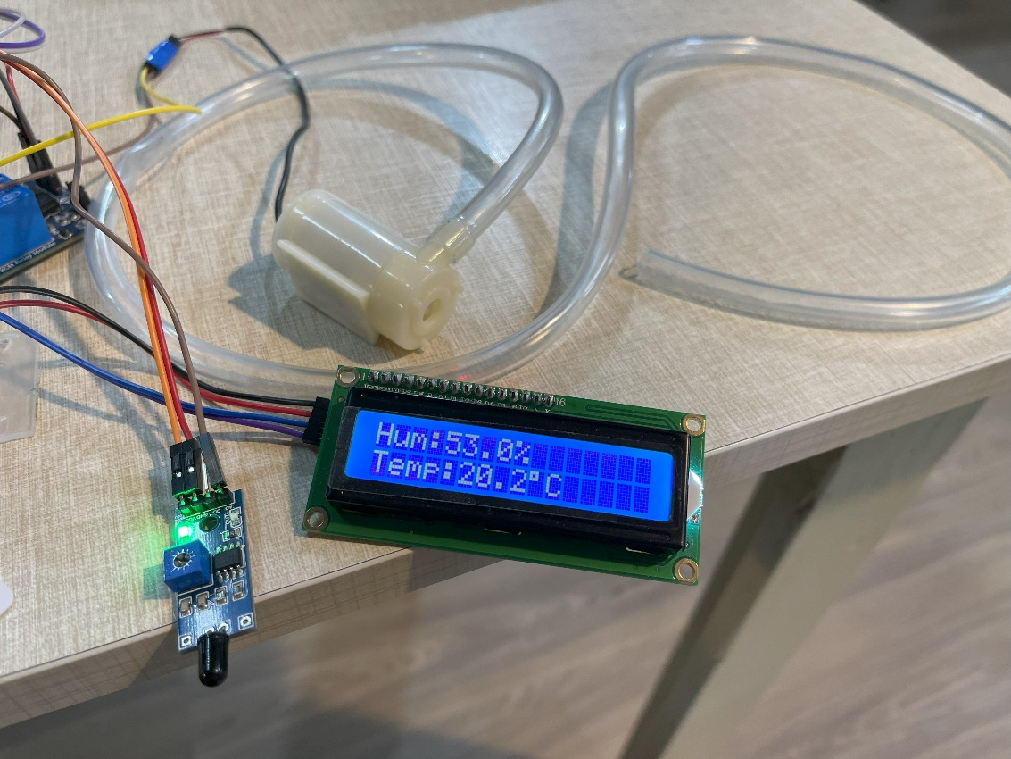

Figure ‎3‑19: Fire suppression system remains idle when there is no fire detected.

## System 3: Road Weather Information

### Humidity and Temperature Module DHT22

**Description:**

A temperature and humidity sensor is a device designed to measure ambient temperature and humidity levels, converting these parameters into electrical signals. These signals can then be easily interpreted and monitored. Widely available in the market, temperature and humidity transmitters primarily assess the air's temperature and relative humidity. They function by converting these measurements into electrical or other forms of signals following specific standards. This data is then relayed to instruments or software systems, catering to the environmental monitoring requirements of users. This technology is essential for maintaining optimal conditions in various settings, ensuring precise and reliable environmental control.

#### DHT22 Sensor Module Circuit Diagram

The DHT22 sensor module circuit diagram showcases the wiring configuration for accurate temperature and humidity readings; refer to Figure ‎3‑20 for details.

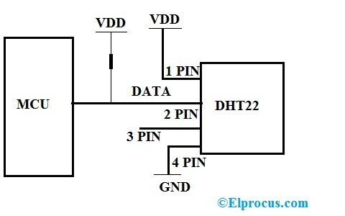

Figure ‎3‑20:DHT22 Sensor Module Circuit Diagram.

1) VCC is Connected to the Supply of the Arduino

2) Data is the pin connected to the Arduino

3) NC not connected

4) GND is Connected to the ground

#### Why DHT22 Sensor Module?

The selection of the DHT22 sensor for integration into the environmental monitoring system is based on a comprehensive evaluation of several key aspects. Primarily, the DHT22's technical specifications make it highly suitable for accurate and reliable measurement of both temperature and humidity, which are crucial parameters for the system. Its cost-effectiveness is a significant advantage, providing a balance between performance and affordability. The sensor's availability in the market ensures ease of procurement and replacement. Importantly, the DHT22 is known for its precision and long-term stability, factors that are essential for consistent environmental monitoring. This sensor's robust performance and compatibility with the system requirements are evident from the data presented in **Table ‎3‑5** and Table ‎3‑6 below.

**Table ‎3‑5: Selection criteria for DHT22 sensor module.**

| **Sensor** | **Reason for Selection/Rejection** |
| --- | --- |
| Adafruit AHT20 | Is not available at the market. |
| AM2301B | There is only one I2C address so it's not a good option when you need multiple humidity sensors. |
| DHT22 | **Libraries available to simulate on Proteus 8 Professional, allowing**  **testing before procurement.** **Factory calibrated, easy to use** |

**Table ‎3‑6: DHT22 sensor specifications.**

| **Specification** | **Value** |
| --- | --- |
| Temperature Range | -40°C to +80°C |
| Supply Voltage | 3.3V to 6V DC |
| Humidity Range | 0-100% |
| Sensing Element | Polymer Capacitor |
| Accuracy | ±0.5°C (typical)  Humidity +-2%RH (Max +-5%RH); |
| Package | TO-92 |
| Sensor Type | Digital |
| Self-Heating | 0.1°C (typical) |

#### ****DHT22 Sensor Module Parts****

The sensor will come as a 4-pin package out of which only three pin will be used as shown in the Figure ‎3‑21 below.

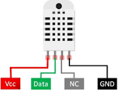

Figure ‎3‑21: Pins functions.

VCC: 5V Power supply

GND: Ground

Data: Digital Output

NC: Not Connected

#### ****How does DHT22 Module Works?****

**First Part is Humidity Sensing Component:**

For humidity measurement, it uses the humidity measurement component, which has two electrodes with moisture holding substrate between them. As humidity changes, the conductivity of substrate changes or resistance between electrodes changes as shown in Figure ‎3‑22. This changes in resistance are measured, then processed by IC which make it ready to be read by microcontroller.

**Second Part is Temperature Sensing Component:**

To gauge temperature, the sensor employs an NTC temperature sensor, commonly known as a Thermistor. A thermistor functions as a variable resistor, altering its resistance in response to temperature fluctuations. These sensors are crafted through the sintering process, using semiconductive materials like ceramics or polymers, which allows for significant resistance changes even with minor temperature variations. As the ambient temperature shifts, the corresponding change in resistance is utilized to accurately measure the environmental temperature.

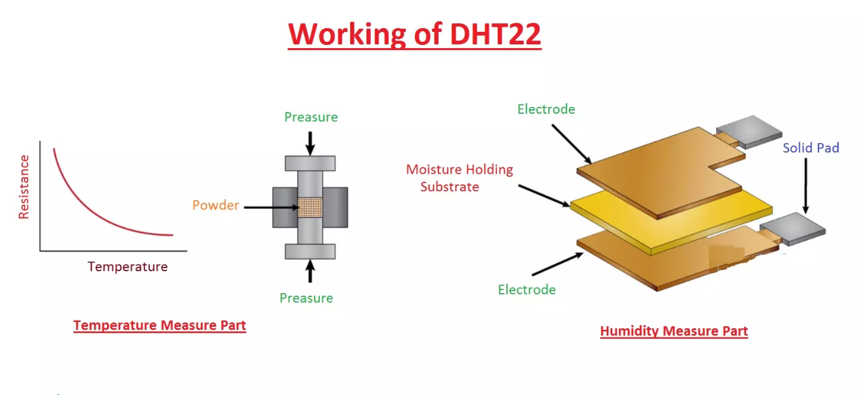

Figure ‎3‑22: DHT22 sensor parts. [30]

#### ****DHT22 Interfacing with Arduino: Proteus Circuit Diagram****

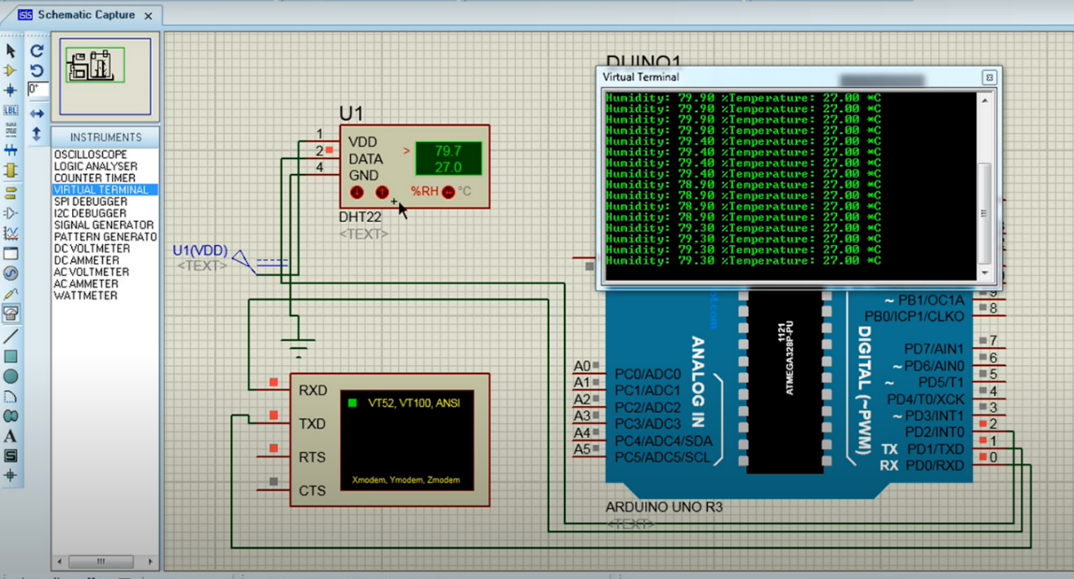

Figure ‎3‑23:Interfacing DHT22 sesnsor on Proteus.

Now that we have a thorough grasp of how the DHT22 sensor works, the above figure shows how to connect the DHT22 sensor module to an Arduino Mega using Proteus. The setup emphasizing the function of the DHT22 sensor in accurate temperature and humidity measurement. This diagram is a useful resource that provides information on how the DHT22 sensor may be easily included into the Arduino Mega configuration for efficient environmental monitoring. As shown in Figure ‎3‑23 DHT22 sensor reads the RH (relative humidity) and temperature in real time.

**Advantages:**

* + High temperature and humidity measurement accuracy
  + Ultra-low power consumption
  + 20-meter signal transmission distance
  + Factory calibrated, easy to use

**Applications:**

* DHT22 is applied in HVAC.
* Testing and Inspection equipment use DHT22 for measuring temperature and humidity values.
* This sensor is used in home appliances and consumer products for measuring temperature and humidity values.
* In medical units to detect the humidity values in isolation units of patients, DHT22 is used.

#### Hardware Implementation

The hardware implementation of a DHT sensor for ambient temperature and humidity measurement plays a crucial role in enhancing the efficiency of environmental control systems, particularly in confined spaces such as tunnels. The DHT sensor, equipped with a combined temperature and humidity sensor, provides real-time data on the environmental conditions within the tunnel. This information serves as a valuable input for an intelligent ventilation system. By integrating the DHT sensor data, the system can accurately assess the heat and humidity levels, enabling it to make informed decisions on activating assisting fans. In response to varying temperature and humidity levels, the ventilation system dynamically modulates the speed of fans, effectively mitigating adverse effects and can efficiently deploy additional fans, ensuring a more comfortable and safe environment inside the tunnel. This hardware implementation showcases the practical application of DHT sensors in creating responsive and adaptive systems for climate control in confined spaces, where fan speed modulation adds an extra layer of precision and efficiency. as shown in Figure ‎3‑24 and Figure ‎3‑25.

Assisting fan inactive

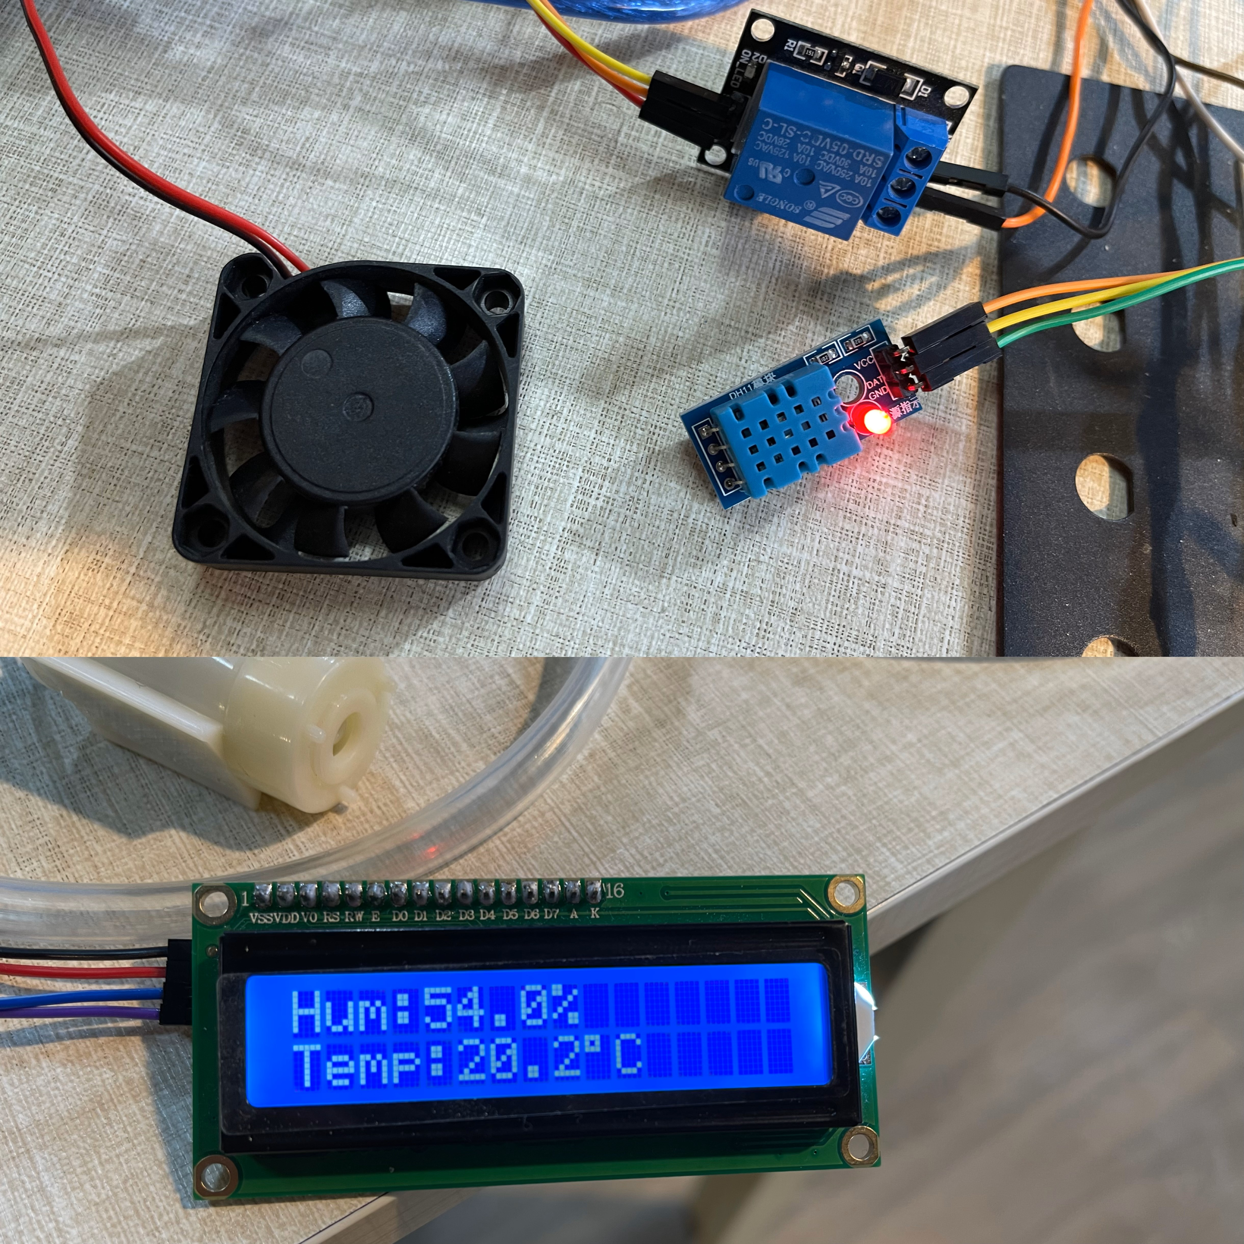

Figure ‎3‑24: Assisting fan inactive when temperature below 23 degree.

Assisting fan activated

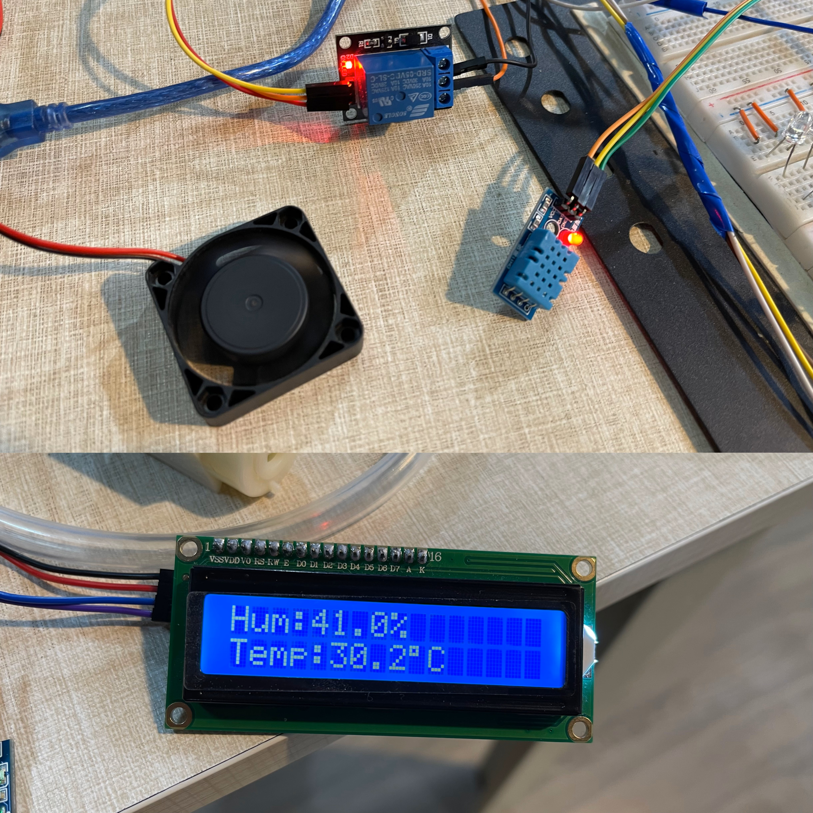

Figure ‎3‑25: Assisting fan active when temperature above 23 degrees.

## System 4: Automatic Vehicle Identification and Toll Collection

### Radio Frequency Identification

**Description:**

A Radio Frequency Identification (RFID) consists of two main components, a tag attached to the object to be identified, and a reader that reads the tag. A reader consists of a radio frequency module and an antenna that generates a high frequency electromagnetic field. Whereas the tag is usually a passive device (it does not have a battery). It consists of a microchip that stores and processes information, and an antenna for receiving and transmitting a signal.

#### RFID Working Principle

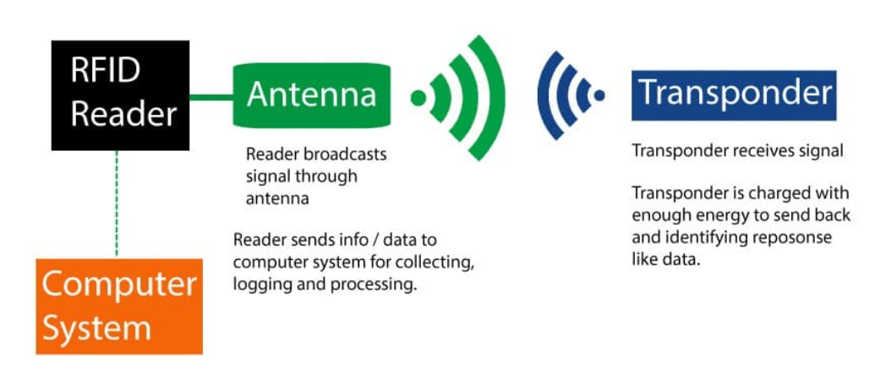

Figure ‎3‑26: RFID working principle.

When the tag is brought close to the reader, the reader generates an electromagnetic field. This causes electrons to move through the tag’s antenna and subsequently powers the chip. The chip then responds by sending its stored information back to the reader in the form of another radio signal. This is called a backscatter. The reader detects and interprets this backscatter and sends the data to a computer or microcontroller as shown in Figure ‎3‑26.

#### Hardware overview

The RC522 RFID module based on the [MFRC522 IC from NXP](https://www.nxp.com/products/identification-and-security/nfc/nfc-reader-ics/standard-performance-mifare-and-ntag-frontend:MFRC52202HN1) is one of the cheapest RFID options you can get online for less than four dollars. It usually comes with an RFID card tag and a key fob tag with 1KB of memory. And the best part is that it can write a tag that means you can store any message in it. For most of our RFID based Arduino projects, the RC522 RFID reader/writer module is a great choice. It is low power, low cost, very rugged, easy to interface and extremely popular among hobbyists.

#### How to choose the right RFID Technology?

Choosing the right RFID technology requires understanding the various types available, each catering to different needs. Passive RFID, the most common type, relies on reader-initiated energy, making it cost-effective and suitable for short-range applications. Active RFID, equipped with its own power source, offers a longer range and is ideal for tracking high-value assets over greater distances. Semi-passive RFID, a blend of the previous two, uses a battery to boost tag signal strength, enhancing readability without the higher cost of active tags. These types and their specific applications will be explored in detail in the following, guiding you to select the most appropriate RFID technology for your needs.

##### Active RFID Tags

**Description:**

Active RFID tags integrate a transmitter (transponder or beacon) with a battery, forming a single unit. The battery powers the transmitter, enabling active data transmission to an RFID reader. Tags with beacons transmit continuously, while transponders transmit when activated by a reader’s signal.

**Advantages:**

* Longer read ranges
* Significant data memory
* Availability of rugged and weather-resistant housings

**Disadvantages:**

* Higher cost
* Limited battery life (usually 3 to 5 years)
* Larger size
* Potential to add noise to work environments

Note: Despite drawbacks, active RFID systems can offer significant Return on investment (ROI), especially for tracking high-value or sensitive assets.

##### Passive RFID Tags

**Description:**

Passive RFID tags rely on the tag reader for power, electromagnetically supplied through a process known as coupling. Readable from about 20 feet away or closer, passive tags find applications in smaller-scale and large-scale RFID-based inventory and asset management systems.

**Advantages:**

* Greater range of shapes, sizes, and materials
* Lower cost per tag
* Embeddable formats suitable for various products or packaging
* Potentially longer operational life (no battery)

**Disadvantages:**

* Shorter read range compared to active tags
* Dependent on reader for power

Note: Passive RFID tags are commonly used in item-level tracking, supply chain management, and various access control applications.

##### Semi-Passive RFID Tags

**Description:**

Semi-passive RFID tags share similarities with passive tags in size and manufacturing ease but include a small, eco-friendly battery, similar to active tags. This battery enhances data transmission, extends the read range, and allows for more extensive data transmission.

**Advantages:**

* Support for sensors and memory functions for product condition tracking
* Readable from a medium distance (longer than passive tags)
* Cost less than active tags

**Disadvantages:**

* Limited by battery life

Note: Semi-passive tags strike a balance, offering enhanced features over passive tags at a lower cost compared to active tags.

#### Working principle

The RC522 RFID reader module is designed to create a 13.56MHz electromagnetic field and communicate with RFID tags (ISO 14443A standard tags). The reader can communicate with a microcontroller over a 4-pin SPI with a maximum data rate of 10 Mbps. It also supports communication over I2C and UART protocols. The RC522 RFID module can be programmed to generate an interrupt, allowing the module to alert us when a tag approaches it, instead of constantly asking the module “Is there a card nearby?”. The module’s operating voltage ranges from 2.5 to 3.3V, but the good news is that the logic pins are 5-volt tolerant, so we can easily connect it to an Arduino or any 5V logic microcontroller without using a logic level converter below in **Table ‎3‑7** are RC522 specifications.

**Table ‎3‑7: RC522 RFID specifications.**

|  |  |
| --- | --- |
| Frequency Range | 13.56 MHz ISM Band |
| Host Interface | SPI / I2C / UART |
| Operating Supply Voltage | 2.5 V to 3.3 V |
| Max. Operating Current | 13-26mA |
| Min. Current(Power down) | 10µA |
| Logic Inputs | 5V Tolerant |
| Read Range | 5 cm |

#### RC522 RFID Module Pinout

The RC522 module has a total of 8 pins that connect it to the outside world. The connections are as follows in the following Figure ‎3‑27:

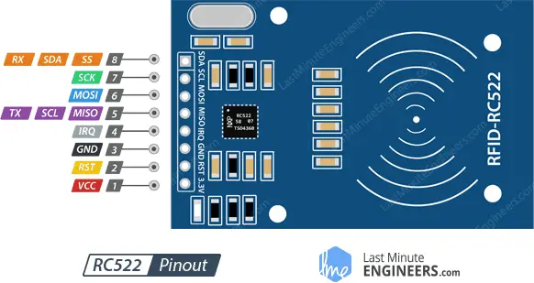

Figure ‎3‑27: RC522 RFID Module Pinout.

1. VCC: Supplies power to the module. This can be anywhere from 2.5 to 3.3 volts. You can connect it to the 3.3V output from your Arduino. But remember that connecting it to the 5V pin will probably destroy your module.
2. RST: Is an input for reset and power-down. When this pin goes low, the module enters power-down mode, in which the oscillator is turned off, and the input pins are disconnected from the outside world. The module is reset on the rising edge of the signal.
3. GND: Is the ground pin.
4. IRQ: Is an interrupt pin that alerts the microcontroller when an RFID tag is in the vicinity.
5. MISO, SCL, TX: Pin acts as master-in-slave-out when SPI interface is enabled, as serial clock when I2C interface is enabled, and as serial data output when the UART interface is enabled.
6. MOSI (Master Out Slave In): Is the SPI input to the RC522 module.
7. SCK (Serial Clock): Accepts the clock pulses provided by the SPI bus master.
8. RX, SS, SDA: Pin acts as a signal input when the SPI interface is enabled, as serial data when the I2C interface is enabled, and as a serial data input when the UART interface is enabled. This pin is usually marked by encasing the pin in a square so it can be used as a reference.

#### RFID Sensor Interfacing with Arduino: Proteus Circuit Diagram

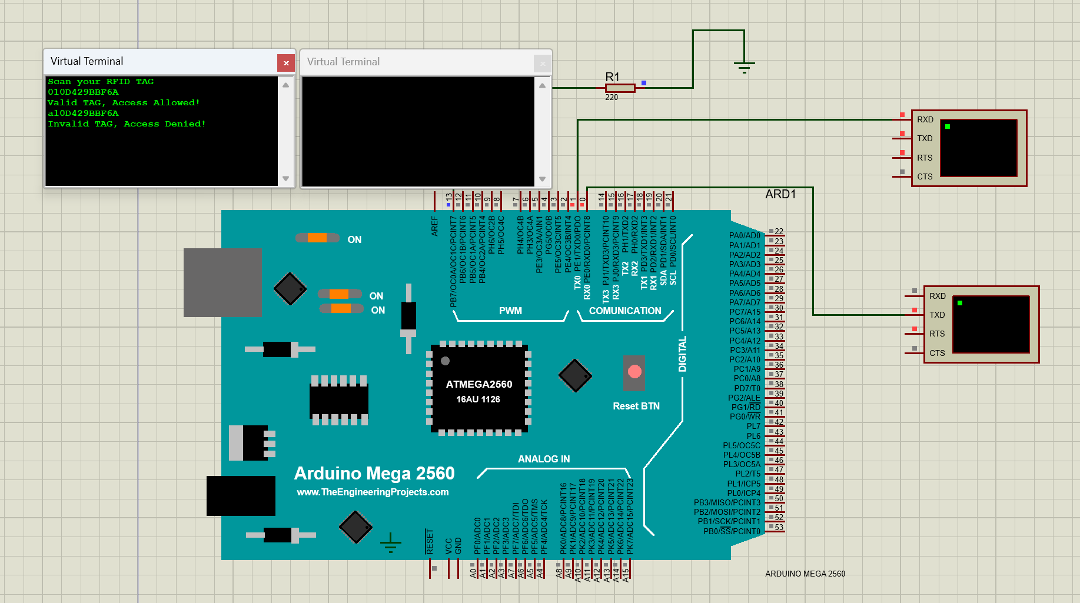

Figure ‎3‑28: Interfacing RFID on Proteus.

In the demonstration, a single RFID system setup is employed to effectively differentiate between authorized and unauthorized access. As illustrated in Figure ‎3‑28, the system's response to two distinct tag IDs is observed.

When the tag ID "010D429BBF6A" is presented to the RFID reader, the system identifies it as a valid and authorized tag. The reader sends a signal, triggering the connected servo to open the access gate, and simultaneously, the LED indicator lights up. This action signifies "Valid TAG, Access Allowed!", allowing entry or access as programmed.

Conversely, upon presenting the tag ID "a10D429BBF6A", the system recognizes it as an invalid tag. In this case, no signal is sent to the servo, leaving the gate in its closed position, and the LED remains unlit. This lack of response is an indication of "Invalid TAG, Access Denied!", effectively preventing unauthorized access.

This setup the RFID system's capability to provide secure access control, distinguishing between authorized and unauthorized tags with clear, visual indicators for each scenario.

**Applications:**

* Automatic billing systems.
* Attendance systems.
* Verification/Identification system.
* Access control systems.
* tracking applications
* supply chain,
* IT hardware
* document controls
* medical facilities
* wristband
* badge access controls.

#### Hardware Implementation

The implementation of RFID technology in toll collection systems significantly enhances the efficiency and speed of traffic flow at toll booths. In this system, vehicles are equipped with RFID tags that contain unique identification information as in Figure ‎3‑29. As a vehicle approaches the toll booth, an RFID reader scans the tag to retrieve the ID. This ID is then cross-referenced with a pre-existing database to verify if the vehicle is registered or has pre-paid for toll access. If the vehicle's ID matches an entry in the system's database, the toll gate automatically opens, granting access. The system is programmed to close the gate a few seconds after the vehicle passes, ensuring secure and timely passage as in Figure ‎3‑30. Conversely, if the vehicle's ID is not recognized or is not in good standing in the database, access is denied, and the toll gate remains closed as in Figure ‎3‑31. This RFID-based system streamlines the toll collection process, reducing congestion and wait times, and provides a more seamless travel experience for regular commuters.

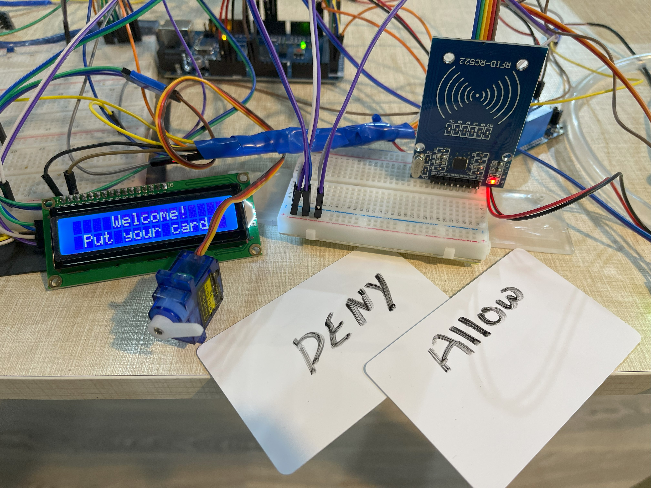

Figure ‎3‑29: Automatic tolling and vehicle identification hardware.

Door opened

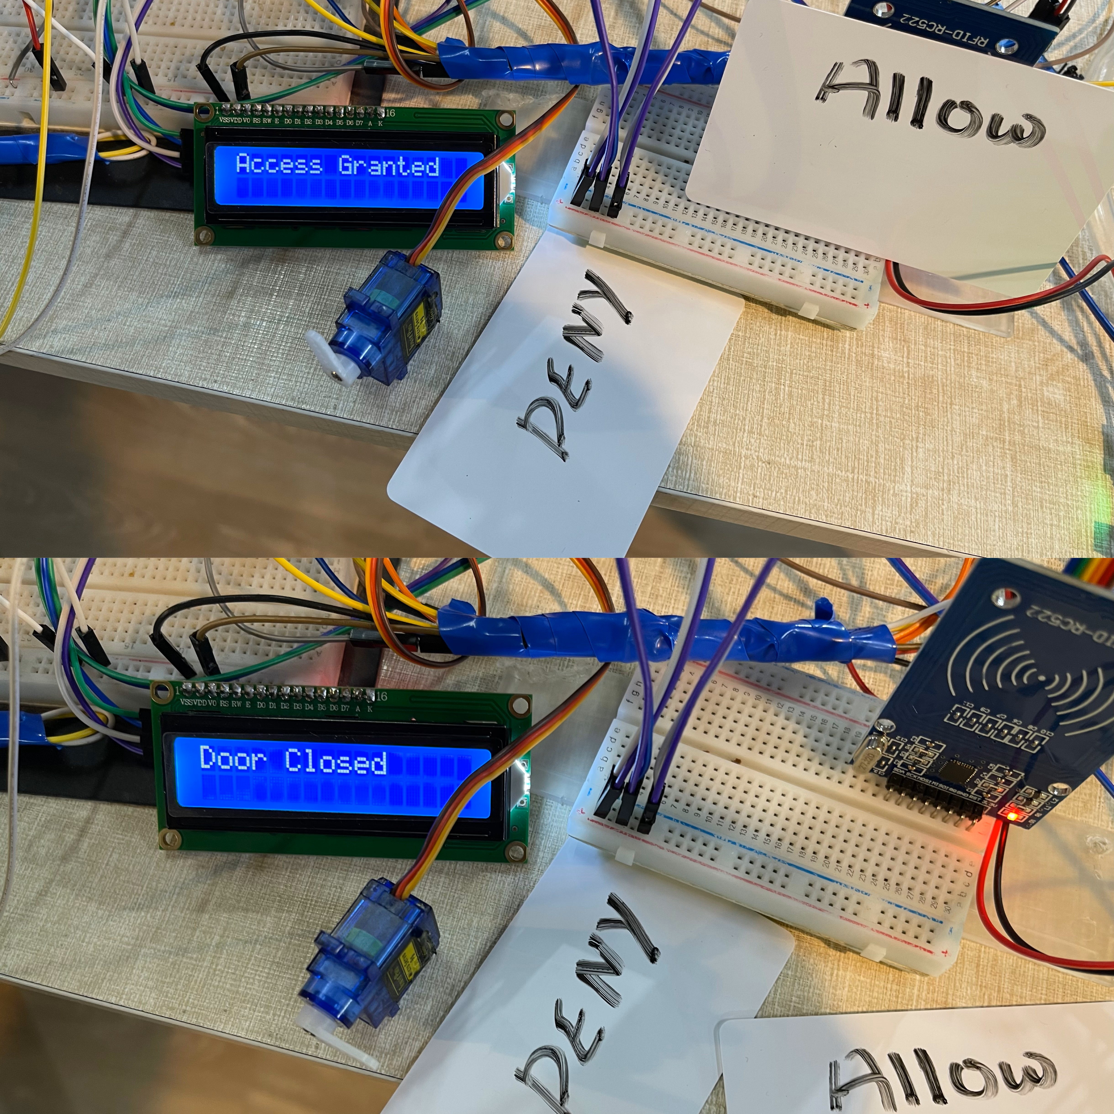

(a)

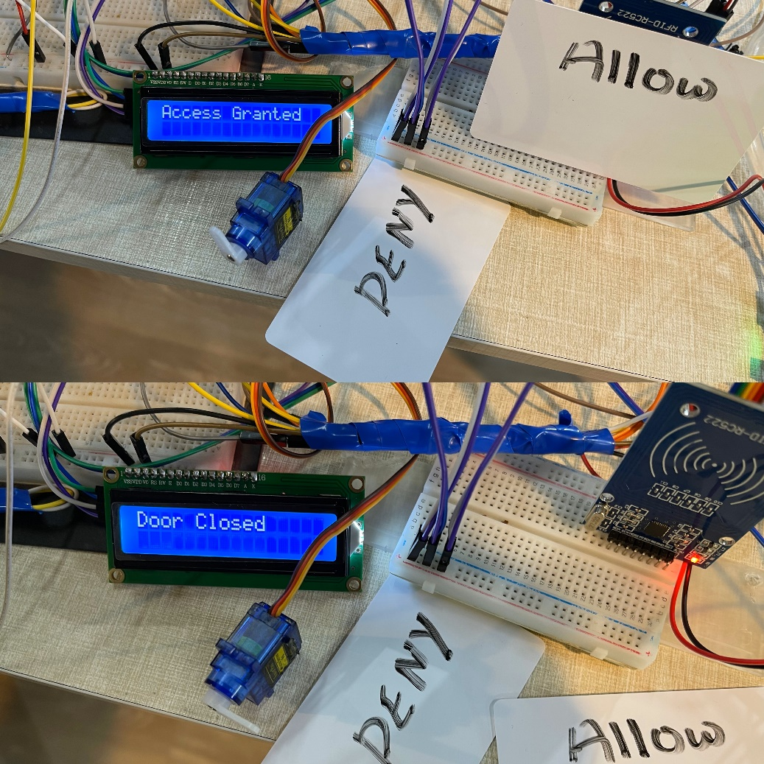

Door closed

(b)

Figure ‎3‑30: (a) Access granted for valid ID. (b) Door closed after a few seconds of passage.

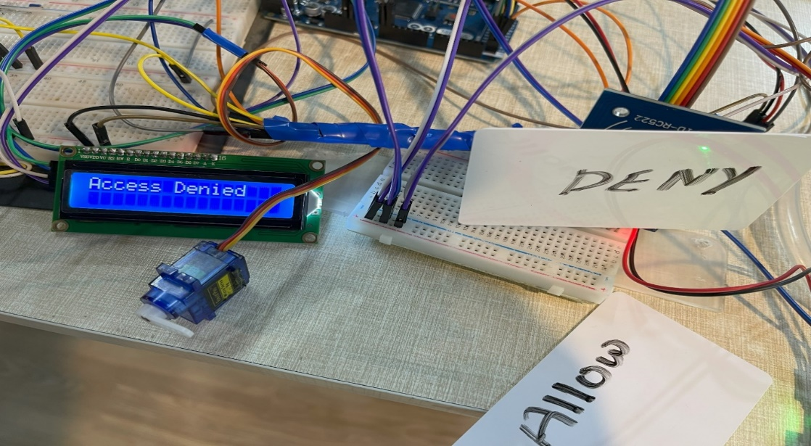

Figure ‎3‑31: Access denied for invalid ID.

## System 5: Lighting Control

### Light sensor TSL2561

**Description:**

A light sensor, also known as a photoelectric device or photo sensor, is a passive component designed to convert light energy into an electrical signal output through the photovoltaic effect. This process involves the transformation of incoming light energy, in the form of photons, into electronic signals carried by electrons. Various types of light intensity sensors exist, including phototransistors, photoresistors, and photodiodes, which leverage the photovoltaic effect.

One practical application of these sensors is in detecting the presence or absence of light, providing insights into changes between day and night. For instance, during daylight, the sensor captures the incoming light, generating an electrical signal indicative of well-lit conditions. In contrast, during nighttime or in low-light environments, the reduced input of light results in a distinct signal, signaling darker conditions. This functionality allows light sensors to play a crucial role in applications such as automatic lighting systems, where the detection of ambient light levels helps determine when artificial lighting is necessary. The incorporation of the photovoltaic effect underscores the pivotal role of light sensors in detecting variations in ambient light conditions.

#### Light Sensor TSL2561 Circuit Diagram

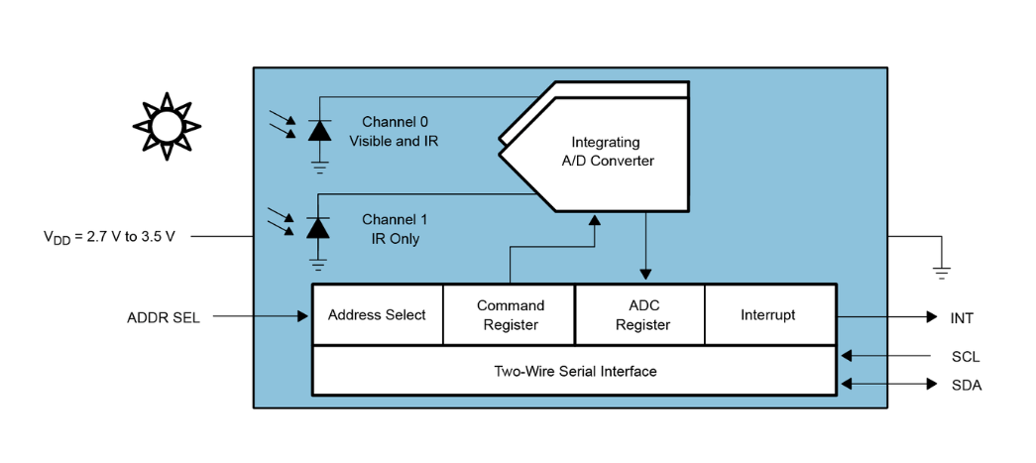

Figure ‎3‑32: Light Sensor TSL2561 Circuit Diagram. [32]

The Light Sensor TSL2561 Circuit Diagram in Figure ‎3‑32 provides a detailed representation of the connections and components necessary for the effective implementation of the TSL2561 light sensor module as in Figure ‎3‑33. This diagram is instrumental in understanding the wiring and functionality of the sensor, highlighting the role of various pins including VCC for power supply, GND for grounding, SDA for serial data communication, SCL for serial clock synchronization, and INT for interrupt signals based on light intensity thresholds. This circuit diagram is essential for anyone looking to integrate the TSL2561 into diverse applications, ranging from intelligent lighting systems to sophisticated monitoring devices.

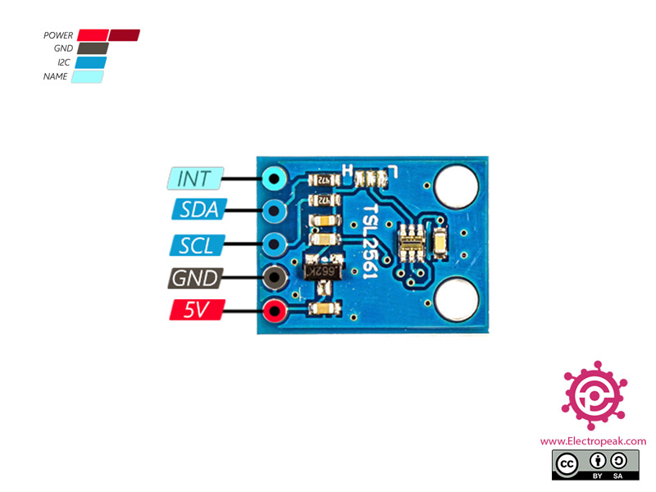

Figure ‑: TSL2561 module pinout.

#### Why TSL2561 Module?

Selecting the optimal light sensor ultimately depends on the specific requirements of the application. It is essential to consider which features hold the utmost significance and then perform a comparative analysis of sensors based on these criteria. In addition to technical specifications, factors such as cost, package type, availability, and ease of use are pivotal considerations in making an informed decision. For a detailed comparison of different sensors and specific specifications of the utilized TSL2561, refer Table ‎3‑8.

**Lux Performance:**

1. BH1750: Measures illuminance in lux with a range of 0.1 to 400,000 lux.
2. LTR-329ALS: Measures illuminance in lux with a range of 0.5 to 50,000 lux.
3. TSL2572: Measures illuminance in lux with a range of 0.1 to 130,000 lux.
4. TSL2561: Measures illuminance in lux with a range of 0.01 to 40,000 lux (high sensitivity mode).

**Voltage and Current:**

1. BH1750: Operates at 1.8 to 3.3 V and consumes 0.7 μA in standby mode.
2. LTR-329ALS: Operates at 2.7 to 5.5 V and consumes 1.6 μA in standby mode.
3. TSL2572: Operates at 2.7 to 3.6 V and consumes 1.2 μA in standby mode.
4. TSL2561: Operates at 2.7 to 3.6 V and consumes 1.5 μA in standby mode (high sensitivity mode).

**Additional Features:**

1. BH1750: Compact size, low power consumption, good accuracy for basic applications.
2. LTR-329ALS: High accuracy, wide dynamic range, flicker rejection, interrupt functionality.
3. TSL2572: Visible and IR sensitivity, proximity sensing, gesture recognition.
4. TSL2561: Excellent accuracy and resolution, high sensitivity mode, programmability.

**Based on these specifications:**

1. For high accuracy and wide dynamic range: LTR-329ALS might be the best choice.
2. For low power consumption and basic applications: BH1750 could be a good option.
3. For visible and IR detection: TSL2572 is suited for proximity and gesture sensing.
4. For the highest sensitivity: TSL2561 excels in low-light conditions.

**Table ‎3‑8: TSL256 light sensor module specifications**

|  |  |
| --- | --- |
| Supply voltage | 2.7V to 3.6V |
| Interface | I2C |
| Measuring range | 0.1 – 40,000+ Lux |
| Spectral response | 320nm – 1050nm |
| Peak sensitivity | 560nm |
| Dynamic range | 16-bit |
| Integration time | 13.7ms to 400ms |
| Current consumption | 0.5mA (typical) |
| Operating temperature range | -30°C to +80°C |

Our selection of the TSL2561 light sensor is further reinforced by its exceptional sensitivity in low-light conditions. This sensor excels in capturing accurate data in environments with minimal illumination, making it particularly suitable for applications where high sensitivity is paramount. The sensor has a digital (i2c) interface. So, can select one of three addresses and have up to three sensors on one board – each with a different i2c address.

#### Hardware Implementation

The hardware implementation of a light sensor module in street lighting systems introduces a sophisticated approach to energy efficiency and urban lighting management. Integrated into the streetlight infrastructure, the light sensor module detects ambient light conditions in real-time. When daylight is sufficient, signaling daytime, the sensor triggers the automatic deactivation of street lights, conserving energy and reducing unnecessary illumination as in Figure ‎3‑34. Conversely, as darkness falls, and the ambient light diminishes, the sensor activates the street lights, ensuring optimal visibility and safety for pedestrians and motorists as in Figure ‎3‑35. This intelligent system not only promotes energy conservation but also fosters an environmentally conscious approach to urban lighting control.

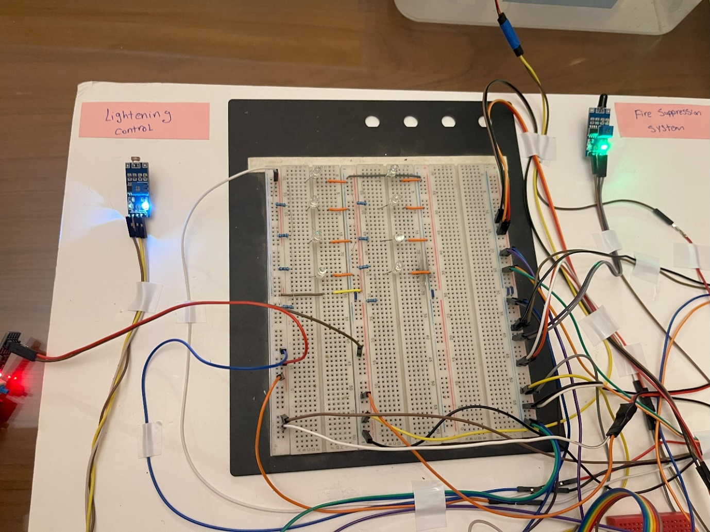

Figure ‎3‑34: Lights automatically turn off when ambient light levels are sufficient.

Ambient light is blocked

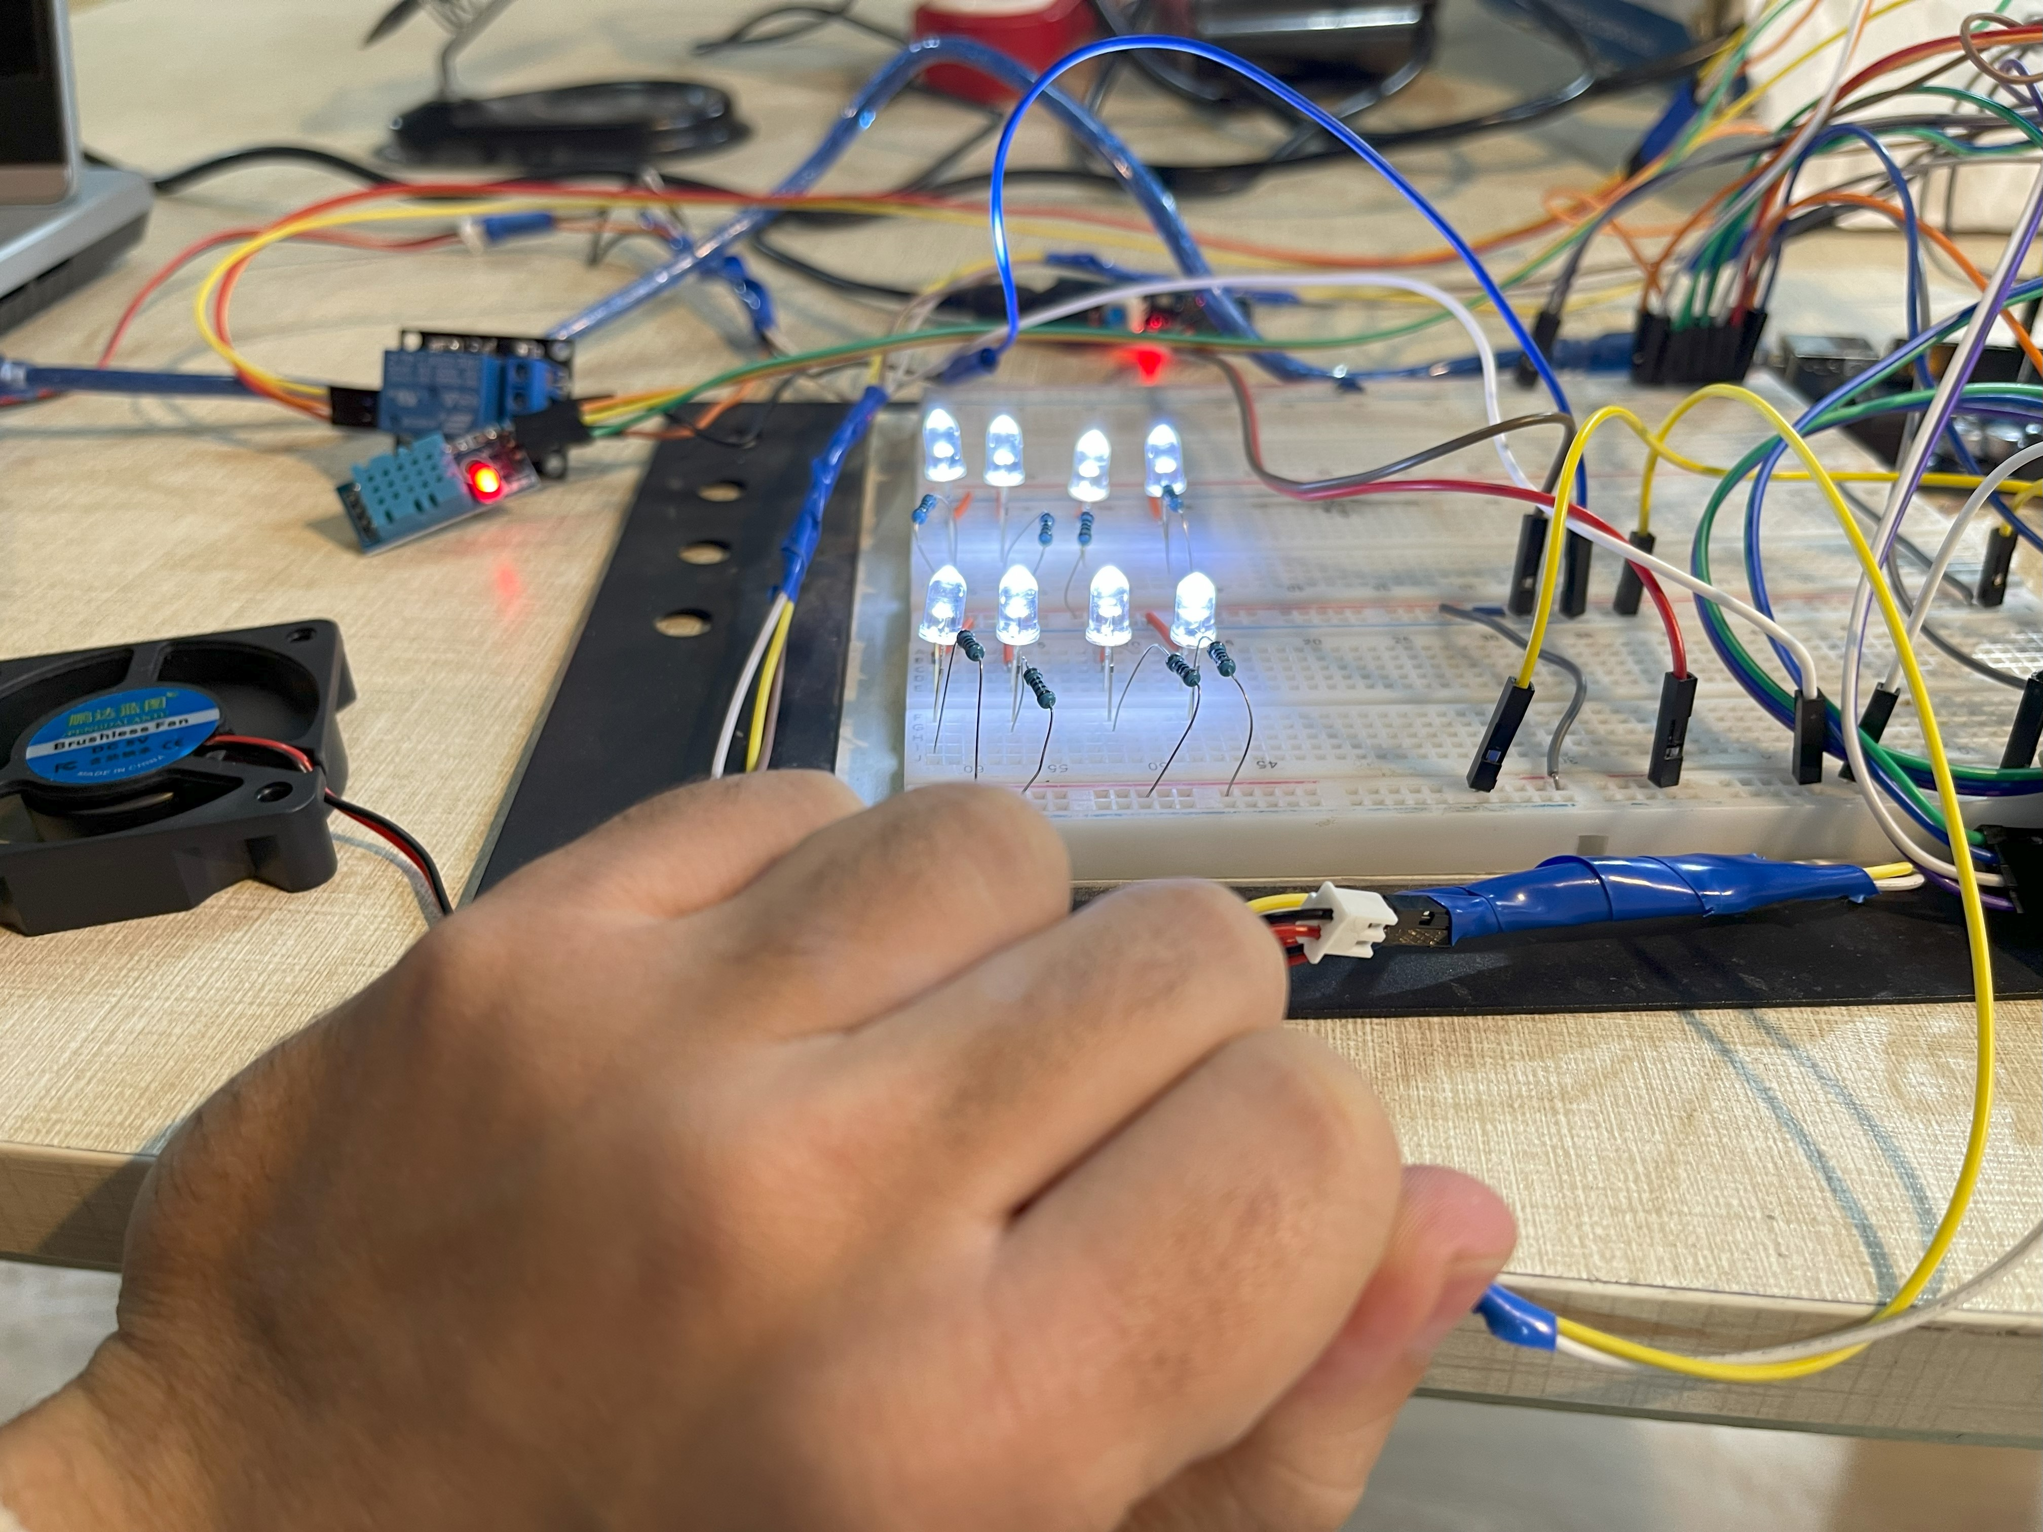

Figure ‎3‑35: Lights automatically turn on when ambient light levels become insufficient.

## Integration and System Prototype

The integration of these diverse hardware implementations into a comprehensive prototype showcases the synergy of intelligent systems for a holistic approach to infrastructure management. The prototype seamlessly integrates the weighing system for tolling, fire suppression system with flame sensors, DHT sensor for climate monitoring, RFID technology for efficient toll collection, and light sensor modules for adaptive street lighting. This integrated solution harmoniously utilizes real-time data from various sensors to enhance safety, efficiency, and environmental consciousness. The prototype aims to demonstrate the interoperability of these systems as shown in Figure ‎3‑36, ensuring a cohesive response to dynamic scenarios. The combination of precise weight measurement, immediate fire response, climate-aware ventilation, streamlined toll collection, and adaptive street lighting forms a resilient and interconnected infrastructure model that addresses 0multifaceted challenges in transportation, safety, and urban management.

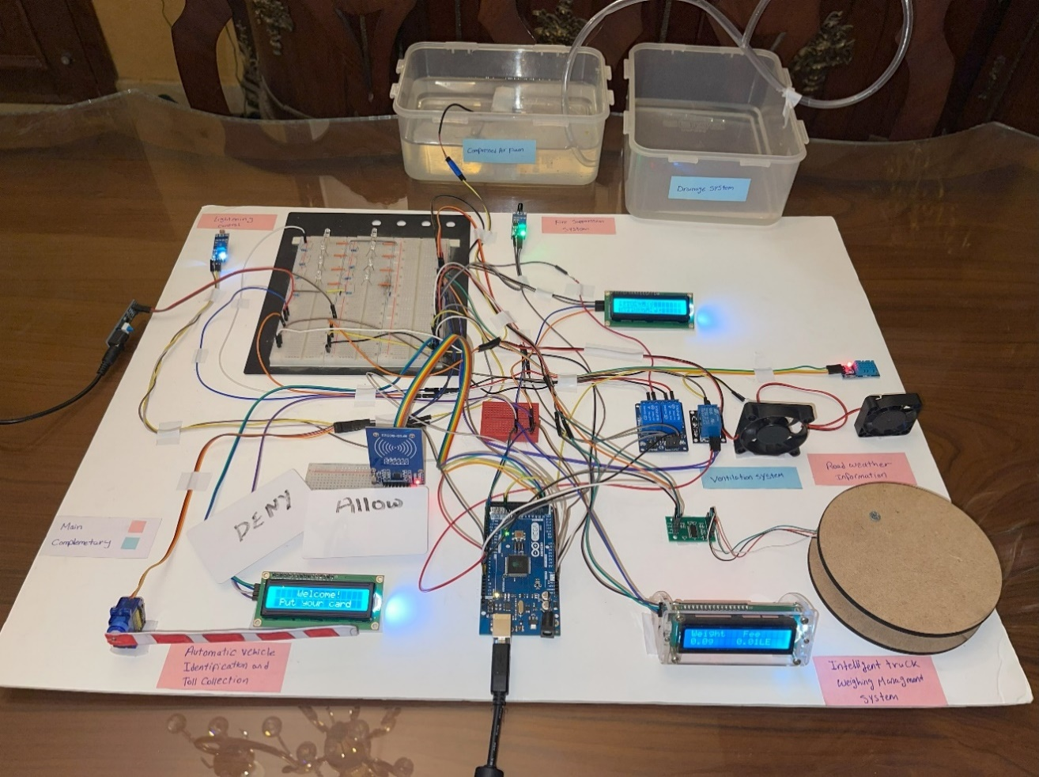

Figure ‑: Integrated systems prototype.

Chapter Four

# FUTURE WORK

The existing systems forms the bedrock of an intelligent and efficient infrastructure, in which integrated components operate seamlessly together. Looking ahead, a crucial focus lies in elevating this integration to create a more interconnected and dynamic environment. An exciting avenue for future exploration involves constructing a small-scale model of a city where all systems are seamlessly integrated. In this model, the deployment of advanced Artificial Intelligence (AI) algorithms becomes pivotal, allowing for the detection and counting of vehicles through camera systems. This not only enables predictive analytics but also facilitates adaptive decision-making, such as anticipating road expansions, adding bridges, or optimizing traffic flow. The incorporation of a Graphical User Interface (GUI) further enhances this integrated approach, offering a centralized and user-friendly platform for monitoring and control. The synergy between AI and GUI not only refines the performance of each system but ensures they work harmoniously together. This forward-looking strategy not only paves the way for a more sophisticated and responsive infrastructure but also contributes significantly to increased efficiency, safety, and sustainability in the realm of urban planning and management.

# REFERENCES

[1] O. Maaitah, "Introduction to ITS," presentation.

[2] P. Burnos and D. Rys, “The Effect of Flexible Pavement Mechanics on the Accuracy of Axle Load Sensors in Vehicle Weigh-in-Motion Systems,” *Sensors*, vol. 17, no. 9, Art. no. 9, Sep. 2017, doi: 10.3390/s17092053.

[3] z3525182, “New inexpensive Wi-Fi system improves fire detection,” UNSW Newsroom. Accessed: Dec. 22, 2023. [Online]. Available: <https://newsroom.unsw.edu.au/news/science-tech/new-inexpensive-wi-fi-system-improves-fire-detection>

[4] L. Celentano, B. Siciliano, and L. Villani, “A robotic system for fire fighting in tunnels,” *IEEE Int. Saf. Secur. Rescue Rototics Workshop 2005*, pp. 166–171, 2005, doi: 10.1109/SSRR.2005.1501258.

[5] “One Seven CAFS extinguishing systems for road tunnels,” BMT Fire & Rescue. Accessed: Dec. 22, 2023. [Online]. Available: <https://bmt-fireandrescue.com/en/products/stationary-extinguishing-systems/cafs-extinguishing-systems-for-road-tunnels/>

[6] *Testing fire systems inside the SR 99 tunnel*, (Jun. 28, 2018). Accessed: Dec. 22, 2023. [Online Video]. Available: <https://www.youtube.com/watch?v=dMDMDnKB-Ao>

[7] “U.S. Road Weather Management Program - Sensor Sitting and Weather Information Integration Projects - Road Weather Management - FHWA Office of Operations.” Accessed: Dec. 23, 2023. [Online]. Available: <https://ops.fhwa.dot.gov/weather/resources/publications/sirwec06/index.htm>

[8] “ANPR Camera System | Nortech Control Systems Ltd.” Accessed: Dec. 27, 2023. [Online]. Available: <https://www.nortechcontrol.com/solutions/vehicle/automatic-number-plate-recognition-anpr/>

[9] *ANPR System, Automatic Number Plate Recognition - OmnyPark*, (Jun. 14, 2012). Accessed: Dec. 26, 2023. [Online Video]. Available: <https://www.youtube.com/watch?app=desktop&v=VWGFr7g0qxU>

[10] “Automatic Number Plate Recognition | High Accuracy ANPR Software,” Plate Recognizer. Accessed: Dec. 27, 2023. [Online]. Available: <https://platerecognizer.com/anpr/>

[11] S. Bhosale, R. Chavan, S. Bhadvan, and P. Mohite, “AUTOMATIC VEHICLE IDENTIFICATION AND TOLL COLLECTION USING,” vol. 03, no. 02.

[12] T. Thornton, “Reductions in fuel consumption and CO,” in *IET Road Transport Information and Control Conference and the ITS United Kingdom Members’ Conference (RTIC 2010). Better transport through technology*, London, UK: IET, 2010, pp. 42–42. doi: 10.1049/cp.2010.0375.

[13] H. Rakha and Y. Ding, “Impact of Stops on Vehicle Fuel Consumption and Emissions,” *J. Transp. Eng.*, vol. 129, no. 1, pp. 23–32, Jan. 2003, doi: 10.1061/(ASCE)0733-947X(2003)129:1(23).

[14] “Transportation sector energy consumption,” 2016.

[15] “Learn the facts: Emissions from your vehicle”.

[16] “Street light control system - Lumenova GmbH.” Accessed: Dec. 27, 2023. [Online]. Available: <https://www.lumenova.net/sales-products/street-light-control-system.html>

[17] “LUCIA_technology_state_of_the_art_report_190826.pdf.” Accessed: Dec. 27, 2023. [Online]. Available: <https://lucia-project.eu/wp-content/uploads/2020/04/LUCIA_technology_state_of_the_art_report_190826.pdf>

[18] Y. Wu, C. Shi, X. Zhang, and W. Yang, “Design of new intelligent street light control system,” in *IEEE ICCA 2010*, Xiamen, China: IEEE, Jun. 2010, pp. 1423–1427. doi: 10.1109/ICCA.2010.5524348.

[19] R. Carli, M. Dotoli, and R. Pellegrino, “A decision-making tool for energy efficiency optimization of street lighting,” *Comput. Oper. Res.*, vol. 96, Nov. 2017, doi: 10.1016/j.cor.2017.11.016.

[20]      “Arduino with Load Cell and HX711 Amplifier (Digital Scale) | Random Nerd Tutorials.” Accessed: Nov. 22, 2023. [Online]. Available: <https://randomnerdtutorials.com/arduino-load-cell-hx711/>

[21]      “pj-460.pdf.” Accessed: Nov. 22, 2023. [Online]. Available: <https://www.gotronic.fr/pj-460.pdf>

[22]      HX711 with a Four Wire Load Cell and Arduino | Step by Step Guide., (Jun. 15, 2020). Accessed: Nov. 22, 2023. [Online Video]. Available: <https://www.youtube.com/watch?v=sxzoAGf1kOo>

[23]      “4-Wire Load Cell (1/5/10/20/200kg) with HX711 and Arduino - Circuit Journal.” Accessed: Nov. 22, 2023. [Online]. Available: <https://circuitjournal.com/four-wire-load-cell-with-HX711>

[24]      “Strain Gauges | Electrical Instrumentation Signals | Electronics Textbook.” Accessed: Nov. 22, 2023. [Online]. Available: <https://www.allaboutcircuits.com/textbook/direct-current/chpt-9/strain-gauges/>

[25] Weighing Machine using Arduino Load Cell & HX711 Module / Weight machine using Arduino, (Jun. 04, 2021). Accessed: Nov. 22, 2023. [Online Video]. Available: <https://www.youtube.com/watch?v=gpofOo4_PtA>

[26]      “Interfacing Flame Sensor with Arduino.” Accessed: Oct. 31, 2023. [Online]. Available: <https://circuitdigest.com/microcontroller-projects/interfacing-flame-sensor-with-arduino>

[27]      syedzainnasir, “New Proteus Libraries for Engineering Students - The Engineering Projects.” Accessed: Oct. 31, 2023. [Online]. Available: <https://www.theengineeringprojects.com/2016/08/new-proteus-libraries-engineering-students.html>

[28]      syedzainnasir, “Flame Sensor Library for Proteus - The Engineering Projects.” Accessed: Nov. 01, 2023. [Online]. Available: <https://www.theengineeringprojects.com/2016/07/flame-sensor-library-proteus.html>

[29]      “Arduino Modules - Flame Sensor,” projecthub.arduino.cc. Accessed: Nov. 01, 2023. [Online]. Available: <https://projecthub.arduino.cc/SURYATEJA/arduino-modules-flame-sensor-e48e97>

[30] zahidali, “Introduction to DHT22 - The Engineering Projects.” Accessed: Dec. 28, 2023. [Online]. Available: <https://www.theengineeringprojects.com/2019/02/introduction-to-dht22.html>

[31] S. Schauer, “How to Make Your Best Choice: Active, Semi-Passive or Passive RFID Tags.” Accessed: Dec. 28, 2023. [Online]. Available: <https://www.barcoding.com/blog/rfid-tags-active-semi-passive-and-passive>

[32] “18a41097-2035-4333-c70e-bfa544c0a98b.pdf.” Accessed: Dec. 28, 2023. [Online]. Available: <https://ams.com/documents/20143/36005/TSL2561_DS000110_3-00.pdf/18a41097-2035-4333-c70e-bfa544c0a98b>